EXAMPLE

Guide for the Production of an Office Specific
Infection Prevention and Control
OFFICE MANUAL

The College of Dental Surgeons of Alberta (CDSA) Standard of Practice: Infection Prevention and Control Standards and Risk Management for Dentistry requires each dental office or clinic to have written Infection Prevention and Control policies and procedures. To assist the membership, the CDSA has developed an IPC Office Manual that can be used as a template for the policies and procedures. However, members considering using the IPC Office Manual must review the Manual in detail to ensure that the content is appropriate for the circumstances of the particular dental clinic and make any necessary changes to the template. The examples that are used are not the only ways to do the various procedures. The examples, however, indicate the amount of detail required and are provided as a template to help dental offices customize the required information for their own use. Members must ensure that any changes made for their IPC Office Manual are consistent with the CDSA’s Standard of Practice: Infection Prevention and Control Standards and Risk Management for Dentistry.

Table of Contents
Accountability and Reporting Structure 6
Hand Hygiene 8
Sterility Assurance 12
Biological Indicators 15
Biological Indicator Results 16
Positive Biological Indicator 17
Chemical Indicator 18
Chemical Indicator Failure 19
Ultrasonic Cleaner 20
Ultrasonic Cleaner Test Procedure 21
Ultrasonic Test Foil 22
Prevention of Exposure to Infectious Agents 23
Procedures for Prevention of Occupational Exposure to Infectious Agents 24
Safe Passing of Sharps/ Instruments 25
Safe Passing of Sharps/ Instruments 26
Safe Handling of Sharps (Dental Burs) 27
Safe Handling of Sharps (Dental Burs) 28
Sharps Exposure 30
Percutaneous Injury 30
Post-Exposure Prophylaxis (PEP) 31
Exposure Documentation 32
Boil Water Advisory 35
Reprocessing 36
Cleaning of Reusable Dental Equipment/ Devices 37
Disassembly, Inspection and Cleaning of Reusable Dental Equipment/ Devices 38
Pre-Cleaning 38
Cleaning 39
Post-Cleaning 40
Office Specific Reprocessing Procedures - Examples 42
Office Specific Procedures for Offices Using Instrument Washers 43
Restorative 43
Handpieces (if reprocessed in the DAC Unit) 43
Burs 44
Hygiene Instruments 44
Separator/ Rubber Dam Clamps 44
Surgical Instruments 45
Office Specific Procedures for Offices doing Manual Cleaning of Dental Instruments 46
Sterilizer Loading Patterns 47
Morcom 48
DAC Universal 49
Calibration 49
Initial Operatory Set-up 51
Operatory Change Over 53
Polices and Procedures for Handling and Transportation of Dental Lab Devices 55
Incoming Procedures 55
Outgoing Procedures 55
Laboratory Infection Control Guidelines 57
General 57
Measures Taken in the Dental Operatory 57
Measures Taken in the Dental Laboratory 58
Guide for Selection of Disinfectant Solutions 60
Infection Control Education 61
Samples of Forms to be used for Occupational Health and Safety Requirements in the Dental Office 62
Key Messages 64
Sample Hazard Assessment Form 66
Sample Worker Orientation Record 68
Sample Record of Training 69
Sample Incident Reporting and Investigation Form 70
Sample First Aid Record Form 72
Sample Emergency Response Plan 73
Sample Workplace Violence Policy and Procedures 75
APPENDIX I – MIFU Cleaning, Care, Maintenance and Sterilization - Specific Dental Instruments Examples Only 77
Cleaning and Sterilization of Rim-Lock Impression Trays 78
Care and Maintenance of Hu-Friedy Dental Instruments 80
Special Procedures for Specific Hu-Friedy Instruments 85
Use and Care of Midwest Burs 89
Sterilization and Maintenance of Miltex Surgical Instruments 91
APPENDIX II – MIFU Care and Preventative Maintenance - Dental Equipment Examples Only 95
Maintenance Schedule 96
VistaPure Ultra Pure Water System 97
Filter Replacement Record 98
Hydrim Care and Maintenance 99
Statim 2000 and 5000 Maintenance 101
DAC Universal 104
Mocom MillenniumB² Steam Sterilizer 109
Lisa Pre-Vacuum Sterilizer Maintenance 116
Dental Chair 120

Accountability and Reporting Structure
Effective infection prevention and control is grounded in clear accountability and lines of responsibility; the establishment of clinical standards while essential, is not sufficient.

To promote clarity, the reporting structure of individuals who have authorization, responsibility and accountability to develop, approve, monitor and maintain reprocessing policies and procedures, must be clearly defined for each dental clinic.

The ultimate responsibility in all areas of IPC rests with the principal dentist.

The dental clinic owner and dentists working at the facility must:

- Ensure that IPC Standards are implemented.
- Ensure that the DHCP employed by the dentist are aware and comply with the documentation required for IPC and Occupational Health and Safety.
- Review all policies annually to ensure that policies are up-to-date with all CDSA Standards.

The person who is designated to oversee the development and implementation of IPC practices for the clinic will be called the Infection Prevention and Control Coordinator (IPCC). The IPCC must:

- Monitor the implementation and application of the standards.
- Monitor IPC activities.
- Record the clinics compliance with IPC standards.
- Promptly and effectively address non-compliance with the standards.
- Provide regular reports on IPC activities to the principal dentist.

Any dental health care personnel in the clinic who becomes aware of an infectious disease or inadequate infection prevention and control measures that could pose a risk to public health shall immediately report that nuisance to the IPCC or the principal dentist.

Hand Hygiene

Hand Hygiene
This is the written hand hygiene policy and procedures for the office of:

An effective hand hygiene program is based on using the right product in the right place at the right time by health care providers who have received education in appropriate hand hygiene indications and techniques, combined with a good hand care program. Each office must have their own written policies and procedures regarding hand hygiene.

These policies and procedures include the following:

- Indications for hand hygiene

- How to perform hand hygiene

- Selection of products used for hand hygiene

- Management of product dispensing containers

- Hand care

Hand Hygiene
EXAMPLE

Proper Hand Hygiene must be performed by the dentist and all dental health care personnel (DHCP).

- Before and after contact with any patient, their body substances or items contaminated by them.
- Before and after performing invasive procedures.
- Before preparing, handling, serving or eating food.
- After assisting patients with personal care (providing oral hygiene or oral hygiene instruction).
- Before putting on and after taking off gloves.
- After performing personal functions (e.g., using the toilet, blowing nose).
- When hands come into contact with secretions, excretions, blood or bodily fluids.
- Before handling clean supplies and setting up.

The hands of the DHCP must be washed using appropriate soap, water and disposable towel combination at the beginning of the workday, after eating, after using the washroom or whenever the hands become contaminated with blood, saliva, or other bodily fluid, or have been in contact with contaminated instruments or devices.

- Perform hand hygiene using soap and water, instead of alcohol-based hand rub when a build-up of alcohol-based hand rub product feels uncomfortable on the hands following multiple applications.

Note: Alcohol-based hand rub remains effective in this situation.

The hands of the DHCP must undergo antisepsis, using either appropriate soap, water, disposable towel combination or an appropriate alcohol-based (60-90%) hand rub, prior to beginning patient treatment before putting on gloves, between patients after removing gloves or whenever gloves are changed during a patient visit. Alcohol-based hand rubs are to be used only if the hands are not visibly soiled.

Hand Washing Technique (Soap)

Sinks must not be used for both hand washing and any other purpose (e.g., cleaning of instruments) unless the sinks have been adequately disinfected after using them for cleaning of these items.

Wet hands with warm (not hot) water. Hot water will lead to dryness of skin. Do not use a standing basin of water.

Apply one full pump of soap.

Vigorously lather soap on hands for a minimum of 15 seconds ensuring to cover all surfaces. Pay particular attention to fingertips, between fingers, back of hands and base of the thumbs. Work soap up towards elbows if short sleeves are worn.
Using a rubbing motion, thoroughly rinse soap from hands. Be sure to remove all soap from hands as any remaining soap can cause dryness and cracking skin.
EXAMPLE

Blot hands with paper towel until dry (no ‘common towel’ is allowed). Rubbing vigorously can damage skin.

If using the sink in the lab or reprocessing area (which do not have motion sensors) turn off taps using paper towel to avoid recontamination of the hands.

DO NOT use alcohol-based hand rubs immediately after washing hands, as skin irritation will be increased.

Alcohol-based hand rub (60-90%)

Alcohol-base hand rub products being considered for purchase must have a Drug Identification Number (DIN) or Natural Product Number (NPN) from Health Canada.

Alcohol-based hand rub is the preferred method (when hands are not visibly soiled with dirt, blood, bodily fluids or other body substances) for decontaminating hands.

Ensure that hands are visibly clean (if not, follow hand washing technique).

Apply one to two full pumps to palm of hands (amount is dependent on the size of your hands).

Spread the product to cover all surfaces of hands (fingertips, between fingers, back of hands, thumbs, and up towards glove line).

Continue to rub hands until product is completely dry, (this will take at least 15 seconds if sufficient product is used).

Alcohol-rub can be used between patients and throughout the day.

Frequent hand hygiene may cause skin irritation; therefore, hand lotions are to be used routinely. If for example an office is using 4% Chlorhexidine gluconate solution, only non-anionic hand lotion should be used. Typically hand lotions, soaps, and alcohol rubs from the same manufacturer are compatible with each other, compatibility should still be checked.
Dental Health Care Personnel must not wear hand jewellery other than smooth metal band rings when performing hand hygiene or during clinical treatment. This includes rings, arm and wrist bands, watches and bracelets. Any smooth metal ring must be removed before doing invasive procedures.

Fingernails must be kept short; less than 3-4 mm. The nail must not be longer than the pad of the finger to ensure thorough cleaning may be done. Artificial nails may not be worn; freshly applied nail polish is allowed but must be free of chips and/or cracks.

THE USE OF GLOVES DOES NOT REPLACE THE NEED FOR HAND HYGIENE

Sterility Assurance

Sterility Assurance
Sterility Assurance refers to the integrated system of tests, controls and backup procedures intended to ensure that reprocessed medical devices are sterile when delivered for use.
Sterility Assurance monitors critical points in the process to ensure that procedures and processes are working correctly, and it includes an effective recall procedure so that problems can be quickly identified, appropriate action taken, and patient safety assured.

General
Physical aspects that are routinely monitored are time, temperature and pressure. This data is displayed on the sterilizer as each cycle progresses and they are recorded either by a printer or an electronic data recorder that records cycle parameters.
Chemical Indicators (CIs) are devices that respond with a chemical or physical change when exposed to the sterilization cycle. A “pass” indicates that certain conditions were achieved at the location of the chemical indicator.
Biological Indicators (BIs) consist of spores on a carrier. Self-contained biological indicators also contain incubation medium. Biological indicators provide a direct measure of the lethality of the sterilization process.
The dental office performs daily tests to ensure that all sterilization equipment is functioning properly. All sterilization maintenance/tests are recorded.
- DAILY- Physical, chemical and biological monitoring is done to verify the effectiveness of the sterilization process.
- Type 1 chemical indicator tape is used when sealing all the cassettes that are wrapped to be processed in the steam sterilizer. Type 5 or 6 chemical indicator strips are placed in every package processed before being put through the sterilizers. Type 5 chemical integrator strips are used with implantable devices.
- All loads through the sterilizer are checked for proper processing by visually inspecting the printout of physical parameters, the Type 1 and 5 or 6 chemical indicator strips and tape. The printouts are signed, and the contents of the load are marked on the back of the printout. An office that has an sterilizer that does not have a printout of time, temperature and pressure, should record the physical parameters. If the sterilizer does not display physical parameters, then cycle complete should be observed and recorded.
- At the beginning of every day, the first load to be run through the pre-vacuum sterilizer is a Bowie-Dick/Dart test. The results are recorded.
- DAILY- Biological indicators are used in each sterilizer (and with each type of cycle used that day). The biological indicators are placed in a process challenge device (In an office using trays, for example, a tray with multiple instruments that will present the most challenging sterilization conditions that day) along with a Type 5 or 6 chemical indicator. Each load that contains implantable devices has a biological indicator placed with that load. Results of the tests are kept and signed off by an assistant.

*Maintenance is performed on all sterilization equipment as per manufacturers’ instructions.

*All new devices and instruments are sterilized as per manufacturers’ directions.

Any new sterilization equipment must be subject to rigorous testing and monitoring on installation and following disruptions to their normal activity:

- sterilizers must be installed according to the manufacturer’s instructions;
- following installation of a new sterilizer, the sterilizer must pass at least three consecutive cycles with the appropriate challenges (i.e., biological, chemical) placed in an empty sterilizer, as well as at least one cycle challenged with a full test load, before the sterilizer can be put into routine service;
- for sterilizers of the dynamic air removal type (pre-vacuum), three consecutive air removal tests shall be conducted in an empty sterilizer with the air detection test pack (e.g., Bowie-Dick/Dart).
- a sterilizer shall not be approved for use if the biological indicator (BI) yields a positive result on any of the tests;
- sterilizers must be monitored with a test load and be fully re-qualified in the following circumstances:
- after major repairs to an existing sterilizer;
- when there has been construction, relocation or other environmental changes in the area;
- after unexplained sterility failures;
- after changes in steam supply or delivery; and
- after repairs or modification to the emission control system.

Biological Indicators

Biological Indicators
A biological indicator, contained within a process challenge device PCD (can be commercially manufactured or prepared in-house following the PCD MIFU. An in-house PCD can be made with a cassette or bag that includes metal instruments, a BI and a Type 5 CI.) must be used to test the sterilizer each day that the sterilizer is used.

The sterilizer should be tested at the beginning of the day before any loads are run. If this is not possible, the sterilizer should be tested at the same time each day.

The biological indicator PCD shall be placed in the cold point (the area of the sterilizer chamber near the drain in a fully loaded sterilizer).

Sterilizers must be monitored with an appropriate biological indicator each day and for each type of cycle used (e.g., wrapped and unwrapped cycles if both are used).

After exposure to the sterilization cycle, the biological indicator shall be removed from the sterilized load and documented to link the biological indicator with the specific load completed. This documentation includes date and time of sterilization, sterilizer number (if more than one sterilizer in the office) cycle number and type of cycle used.

The biological indicator shall then be incubated according to the manufacturer’s directions. Results of incubation shall be documented.

Every load containing implantable devices must be monitored using a biological indicator PCD. Implantable devices must be quarantined until the results of the biological indicator test are available.

Biological Indicator Results

Positive Biological Indicator
In the event of a positive result, the BI test should be repeated immediately in an empty sterilizer chamber and using the same cycle that produced the failure. The sterilizer should be removed from service, and all records reviewed of chemical and mechanical monitoring since the last negative BI test. A review of the recording chart printout to confirm that the correct cycle was used and completed. Sterilizer operating procedures should be reviewed, including packaging, loading, and spore testing, with all DHCPs who work with the sterilizer to determine whether operator error could be responsible.

Common reasons for a positive BI in the absence of mechanical failure of the sterilizer include:
- Overloading
- Failure to provide adequate package separation
- Incorrect or excessive packaging material

If the repeat BI test is negative and chemical and mechanical monitoring indicates adequate processing, the sterilizer may be put back into service. If the repeat BI test is positive, and packaging, loading, and operating procedures have been confirmed as performed correctly, the sterilizer should remain out of service (and it should be clearly marked with a warning sign) until it has been inspected, repaired, and re-challenged with BI tests in three consecutive empty sterilization cycles. Quarantine all items from the load in question and whenever possible, items from suspect loads dating back to the last negative BI test should be recalled, re-wrapped, and re-sterilized until the investigation is complete.

Chemical Indicator

Chemical Indicator Failure
The protocol to be followed in the event a chemical indicator fails to reach its endpoint should include but is not limited to the following considerations:

- Was there a sterilizer malfunction that could account for the failure to achieve the endpoint?
- Has there been a change(s) in the product and/or sterile barrier system?
- Has the loading density increased or decreased within the sterile barrier system?
- Has the sterilization processing container/configuration changed (e.g., number of packages has increased or decreased, or the configuration was not the same as that used during validation)?
- Was sterilizer calibration and/or routine maintenance conducted appropriately?
- Was the correct sterilizer process chosen for the product sterilized?
- Was the chemical indicator handled under manufacturer’s recommended practices?
- Have there been changes in the utilities supplied to the sterilizer that could materially affect cycle execution (pressure, flow rate, non-condensable gases in the steam supply, etc.)?
- Did that instrument pack, in fact, actually go through a sterilizer cycle?

Ultrasonic Cleaner

Ultrasonic Cleaner Test Procedure
Prepare an aluminum foil sample approximately one inch greater than the depth of the tank by approximately the length (longest dimension) of the tank. For example; a tank with dimensions of nine inches long by five inches wide by four inches deep would require a foil sample measuring nine inches by five inches. Use scissors to cut the foil- do not tear it.

Prepare a fresh solution of ultrasonic cleaning solution according to the manufacturer’s instructions and fill the tank to within one inch of the brim.

If a heater is supplied with the cleaner, turn it off for the remainder of the test. Also, if the unit is supplied with a HI/LO switch, it should be set in the HI position.

Before placing the foil in the tank, turn the ultrasonic cleaner on for five minutes. Be sure to turn the timer well past the five-minute setting, then back to five-minute setting, for maximum time accuracy.

Hold the foil sample into the tank in a vertical position. The long dimension of the foil should be oriented with the long dimension of the tank. The foil should extend downward but should not touch the tank bottom. The foil should be approximately centered from front to back. While holding the foil as steady as possible, turn the ultrasonic cleaner on for exactly 20 seconds.

Properly functioning units will result in foil surfaces that are uniformly “peppered” (covered with a tiny pebble effect), over the entire surface. If areas greater than ¹/₂-inch square show no pebbling, there may be a problem with the unit. Re-test with new foil to confirm failure. If both tests result in failure, the unit should be serviced before being returned to use. The foil samples should be given to the repair technician to demonstrate the fault.

Foil samples may be retained for future comparison. If subsequent tests show marked changes compared to previous results, the unit may require servicing.

Ultrasonic Test Foil

Prevention of Exposure to Infectious Agents

Procedures for Prevention of Occupational Exposure to Infectious Agents
Dental health workers shall wear appropriate personal protective equipment while at work, which includes masks, eye protection, gloves and footwear to reduce the risk of exposure to infectious agents.

- Always use extreme caution when passing sharps during four-handed dentistry.
- Needles should remain capped prior to use.
- Needles should not be bent, recapped or otherwise manipulated by using both hands.
- Following use, needles should be recapped as soon as possible by using a one-handed scoop technique or a commercial recapping device.
- Scalpel blades are to be removed using a needle driver rather than fingers.
- When suturing, tissues should be retracted using appropriate instruments (e.g., retractor, dental mirror), rather than fingers.
- Remove burs from handpieces immediately following the procedure and have them facing inward during the procedure.
- Identify and remove all sharps from trays before cleaning instruments.
- Used sharps must be collected and a clearly labelled puncture-resistant container at point of use.
- When cleaning contaminated instruments by hand, heavy-duty utility gloves, appropriate clothing and long-handled brushes should be used.

Gowns should be worn during procedures when there is likely to be splatter from blood and/or saliva.

Gloves are single-use and must be worn whenever the hands might be in contact with blood, saliva or other body fluids, or will be in contact with contaminated instruments or devices. Sterile gloves must be worn whenever invasive surgical procedures are performed. Chemical resistant, puncture proof utility gloves are worn when reprocessing instruments. These utility gloves are single-operator gloves and can be reused but must be disinfected after being used. Hands must be sanitized before putting gloves on and after taking gloves off. Hands must be sanitized before re-gloving.

Masks that cover the mouth and nose are to be worn during dental procedures that are likely to produce splashes, sprays or splatter of blood, saliva or other body fluids or water contaminated with blood, saliva or other body fluids. Masks are single-use and must be changed whenever they become contaminated or wet and must be changed according to manufacturer’s instructions.

All personal protective equipment must be removed prior to leaving the patient care area. Masks must not be worn around the neck outside of the patient care area and must not be stored to be used again.

Safe Passing of Sharps/ Instruments

Safe Passing of Sharps/ Instruments
Occupational Health and Safety requirements are that each dental clinic must have written policies and procedures regarding work practice controls to prevent injuries from sharp objects.

Single Handed
- Pick up instrument from tray.
- Grasp instrument at the end of the handle or at the opposite working end.
- Transfer instrument from the tray into the transfer zone, making sure instrument is parallel to the instrument in the dentist’s hand.
- Using the last two fingers in your last hand, retrieve the used instrument from the dentist, tucking the instrument toward the palm.
- Position the new instrument firmly into the operator’s fingers. (Position the working end toward the proper area of the mouth).
- Place the used instrument back into the cassette.

Two Handed
- Using the right hand, grasp instrument from the cassette closer to the working end with the thumb and the first two fingers.
- With the left hand, retrieve the used instrument form the operator using reverse palm grasp to hold the instrument prior to placing it back in the cassette.
- Deliver the new instrument to the operator so that it is oriented with the appropriate position.
- Return the used instrument back in the tray.

Cotton Pliers
- When used to transfer small items to and from the oral cavity, deliver the cotton pliers to the operator by pinching the ‘beaks’ together.
- Use transfer technique when passing similar instruments.

Instruments with Hinges
- Hold the instrument by the hinges while directing into the operator’s palm.
- May need to use the two-handed transfer as hinged instruments are often larger and heavier.

Safe Handling of Sharps (Dental Burs)

Safe Handling of Sharps (Dental Burs)
Procedures for safe handling and removal of burs from handpieces.

All dental health care personnel must don protective eye wear, face mask and gloves when handling dental burs.

All dental burs must be wrapped and sterilized prior to each patient.

Placement of burs into a dental handpiece can be achieved with a two-handed method. One hand shall hold the handpiece pressing the button, while the other may carefully insert the bur into the handpiece and place it safely on the unit until needed.

Removal of dental burs from a handpiece can be achieved with the same method, carefully grasping the bur and pulling away until the bur is released.

Once the bur has been removed, it should be strategically placed in a container until transport to the sterilization center or discarded in a sharps container.

Sharps Exposure

Sharps Exposure

Percutaneous Injury
Exposure to blood or saliva by percutaneous injury is the greatest risk for acquiring a blood-borne pathogen in the dental health-care setting. Every effort should be made by all DHCP to avoid percutaneous injury.

Significant exposures should be dealt with immediately. A significant exposure exists whenever any of the following events occurs:

- Percutaneous injury, where the skin of the DHCP is punctured (i.e., blood is drawn).
- Blood, saliva or other body fluid is splashed onto non-intact skin (dermatitis, cuts or abrasions).
- Blood, saliva or other body fluid is splashed onto mucosa of the eyes, the mouth or the nose.

The steps in managing a significant exposure are:

- Remove gloves or immediate clothing, if necessary, to assess the extent of the injury.
- First-aid should be administered, if necessary, for percutaneous exposures.
- Immediately wash the area, including the puncture or wound using antimicrobial soap and water. Exposed eye, mouth or nose mucosa should be flushed with copious amounts of water. The application of caustic agents such as bleach, or the injection of antiseptic agents into the wound is not advisable.
- Report the injury to the Office Infection Prevention and Control Officer, who should then contact the appropriate health-care professional, for advice and possible referral, and begin the necessary documentation. The Medical Officer of Health for each Zone is also available for consultation and can be contacted through Health Link Alberta. In some instances, the Zone-specific Medical Officer of Health may be able to re-direct the call to Communicable Disease Control Staff and subsequently the employer may be charged a fee-for-service to manage the occupational exposure. The Worker’s Compensation Board should be contacted to report the injury, if applicable.
- Documentation (see the Exposure Documentation Form following) should include:
- The name of the exposed DHCP, and details regarding the exposed person’s hepatitis B vaccination status.
- The date and time of the exposure.
- The nature of the exposure, including the dental procedure being performed, the extent of the exposure, and immediate action taken.
- The name and health status of the source person, including details regarding any known or suspected bloodborne pathogens (hepatitis B, hepatitis C, and HIV).
- Referral for follow-up counselling and post-exposure management as necessary.

Post-Exposure Prophylaxis (PEP)
Every significant exposure must be evaluated by a qualified health-care professional for the potential to transmit bloodborne pathogen. The assessment of risk of transmission will be based on:

- The type and amount of body fluid or tissue involved.
- The nature of the exposure (e.g., percutaneous injury, mucous membrane or non-intact skin exposure).
- The known or unknown infection status of the source.
- The susceptibility of the exposed person.

All of these factors should be considered in determining the need for further follow-up care, including Post-Exposure Prophylaxis (PEP).

If the need to administer PEP is determined to be necessary, it should be done as soon as possible after the exposure. For example, anti-retroviral drugs to treat an HIV exposure should be given within one to two hours after the exposure.

The PEP regimens considered will be determined by the health-care professional contacted by the Office Infection Prevention and Control Officer following the exposure.

The PEP regimen should be consistent with current infection prevention and control guidelines, as recommended by the Public Health Agency of Canada.

As previously discussed, the appropriate arrangements and contact health-care personnel should be determined well before an actual significant exposure occurs.

Exposure Documentation
(NOTE: Confidentiality of this form MUST be ensured)
Name of Exposed Person:
Hepatitis B vaccination completed: date: / / Previous antibody response Yes/No/Unknown
mIU/ml
yyyy/ mm/ dd

Date and time of Exposure:

Procedure being performed:

Where and how exposure occurred:

Did exposure involve a sharp device: Yes No

Type and brand of device:

How and when during handling exposure occurred:

Extent of the exposure (describe):

Blood Saliva Other body fluid Describe:

Percutaneous injury:
Depth of wound:

Gauge of needle:

Was fluid injected: Yes No

Skin or mucous membrane exposure:
Estimated volume of fluid:

Duration of contact:

Condition of skin: Intact Chapped Abraded

Source person information:
Known bloodborne pathogens:

HBV: Yes No Unknown
HCV: Yes No Unknown

HIV: Yes No Unknown
Anti-retroviral therapy: Yes if yes, name(s)/dosage: No
Name of attending physician:

Follow-up care (describe in detail):
Date  yy/mm/dd | Caregiver | Action Taken

Boil Water Advisory

Boil Water Advisory
Each dental office shall have written reprocessing plans for loss of potable water, boil water advisories and other situations where the water supply is compromised.

When there is a boil water advisory:

- Do not deliver public water through dental unit, ultrasonic scaler, or other devices.
  - Use alternative water sources though closed delivery systems.
  - Postpone treatment delivery if necessary.

- Do not allow patients to rinse with tap water.

- Do not use tap water to rinse hands; use antimicrobial products that do not require water, (e.g., alcohol-based hand rubs).

- When cancelled:
- Flush all incoming public water system lines; run all taps and waterlines at least 30 minutes.
- Disinfect all dental unit waterlines according to manufacturer instructions.

Reprocessing

Cleaning of Reusable Dental Equipment/ Devices

Disassembly, Inspection and Cleaning of Reusable Dental Equipment/ Devices

“Cleaning is always essential prior to disinfection or sterilization. An item that has not been cleaned cannot be assuredly disinfected or sterilized.”
Public Health Agency of Canada/Health Canada

Reusable dental equipment/devices must be thoroughly cleaned before disinfection or sterilization. The process of cleaning physically removes contaminants from the equipment/device, rather than killing microorganisms. If an item is not cleaned, soil (e.g., blood, body fluids, dirt) can protect the microorganisms from the action of the disinfection or sterilization process making it ineffective, as well as inactivate the disinfectant or sterilant so that it does not work. Disinfectants that become overloaded with soil can become contaminated and may become a source for transmission of microorganisms. Cleaning is always essential prior to disinfection or sterilization. An item that has not been cleaned cannot be adequately disinfected or sterilized.

Pre-Cleaning
Gross soil shall be removed immediately at point-of-use. If cleaning cannot be done immediately, the dental equipment/device must be submerged in tepid water and detergent or enzymatic cleaner to prevent organic matter from drying on it.

Full PPE shall be worn for handling and cleaning contaminated equipment/devices.

Once dental equipment/devices have been received in the reprocessing area/department, they must be disassembled, sorted and soaked:

Disassembly
Facilitates access of the cleaning agent, disinfectant and/or sterilant to device surfaces:
- Equipment/devices shall be disassembled prior to cleaning if there is one or more removable part, unless otherwise recommended by the manufacturer; and
- Follow the manufacturer’s recommendations when disassembling dental equipment/devices prior to washing.

Sorting
Keeps dental equipment/devices that belong to a set together and streamlines the cleaning process:
- Sort equipment/devices into groups of like products requiring the same processes; and
- Segregate sharps and/or delicate equipment/devices to prevent injury to personnel and damage to the equipment/device.

Soaking
Prevents soil from drying on equipment/devices and makes them easier to clean:
- Soak equipment/device in an approved instrument soaking solution;
- Do not use saline as a soaking solution as it damages some dental equipment/devices;
- Use detergent-based products, including those containing enzymes, as part of the soaking process;
- Ensure that detergents (including enzymatic cleaners) are appropriate to the equipment/device being cleaned (products used must be approved by the equipment/device manufacturer); and
- Avoid prolonged soaking (e.g., overnight) of equipment/devices.

Cleaning
Cleaning may be done manually or using mechanical cleaning machines (e.g., washer-disinfector, ultrasonic washer, washer-sterilizer) after gross soil has been removed. Automated machines may increase productivity, improve cleaning effectiveness and decrease staff exposure to blood and body fluids. Manual cleaning may be required for delicate or intricate items. The equipment/device manufacturer’s cleaning instructions shall be followed, including specifications for detergent type, water temperature and cleaning methods. The following procedures are included in the cleaning process:

Physical Removal of Organic Materials
- Completely submerge immersible items during the cleaning process to minimize aerosolization of microorganisms and assist in cleaning.
- Minimize the production of aerosols when cleaning non-immersible equipment/devices.
- Remove gross soil using long-handled brushes.

Manual Cleaning
- Clean equipment/devices that have lumens with a brush, according to the manufacturer’s instructions, then manually or mechanically flush with a detergent solution and rinse.
- Check equipment/devices with lumens for obstructions and leakage.

Mechanical Cleaning
Whenever possible, clean equipment/devices by mechanical means:
- Use mechanical washers in accordance with the manufacturer’s instructions.
- Manually clean heavily soiled equipment/devices before mechanical cleaning.
- Ensure that the equipment/device to be cleaned is compatible with the mechanical cleaning equipment and chemical solutions that are being used.
- Ultrasonic washers are strongly recommended for any semi-critical or critical dental equipment/device that has joints, crevices, lumens or other areas that are difficult to clean:
- The manufacturer’s instructions must be followed for use and routine cleaning and maintenance of the ultrasonic washer.
- Equipment/devices shall be completely immersed in the washing solution.
- After cleaning, equipment/devices shall be rinsed thoroughly prior to further reprocessing.
- The ultrasonic washing solution should be changed at least daily or more frequently if it becomes visibly soiled or if the manufacturer’s instructions specify more frequent changes.
- Washer-disinfectors are strongly recommended for dental equipment/devices that can withstand mechanical cleaning, to achieve the required exposure for cleaning and to reduce potential risk to personnel:
- Washer-disinfectors must meet the requirements of the CSA.
- The manufacturer’s instructions must be followed for the use and routine maintenance, cleaning and calibration of the washer-disinfector.
- Washer-disinfectors may be used for low-level disinfection.
- Washer-disinfectors are not to be used for high-level disinfection.

Care of Cleaning Tools
- Inspect brushes and other cleaning equipment for damage after each use, and discard if necessary.
- Clean, disinfect, dry and store tools used to assist in cleaning (e.g., brushes, cloths).

Rinsing
Rinsing following cleaning is necessary, as residual detergent may neutralize the disinfectant:
- In a sink that has been disinfected, rinse all equipment/devices thoroughly after cleaning with fresh water to remove residues which might react with the disinfectant/sterilant;
- Rinsing is to be performed submerged in fresh water.

Drying
Drying is an important step that prevents dilution of chemical disinfectants which may render them ineffective and prevents microbial growth:
- Follow the manufacturer’s instructions for drying of the equipment/device.
- Equipment/devices may be air-dried or dried by hand with a clean, lint-free towel.
- Dry lumens with compressed air that has been filtered and dried.
- Dry stainless-steel equipment/devices immediately after rinsing to prevent spotting.

Post-Cleaning
Once dental equipment/devices have been reprocessed, there must be a process to ensure that they can be differentiated from equipment/devices which have not been reprocessed. Sterilized items may be identified using external chemical indicators (CIs), such as sterilizer tape, which changes colour during sterilization. Equipment/devices which receive high-level disinfection should also be labelled, tagged or colour-coded to indicate that they have been reprocessed.

The following procedures must be included following the cleaning process:

Reassembly and Inspection
- VISUALLY INSPECT all equipment/devices once the cleaning process has been completed and prior to terminal disinfection/sterilization to ensure cleanliness and integrity of the equipment/device (e.g., cracks, defects, adhesive failures).
- Repeat the cleaning on any item that is not clean.
- Do not reassemble equipment/device prior to disinfection/sterilization; if the equipment/device manufacturer’s instructions specify reassembly at this stage in the reprocessing, it shall take place in a clean area and be performed in accordance with the manufacturer’s instructions.

Lubrication
- Follow the manufacturer’s guidelines for lubrication.
- Equipment/devices requiring lubrication shall be lubricated prior to sterilization.
- Lubricants shall be compatible with the device and with the sterilization process.
- Discard lubricants on or before the expiry date or when visibly soiled or contaminated.

Wrapping
- Equipment/devices that are to be sterilized require wrapping prior to sterilization.
- Materials used for wrapping shall be prepared in a manner that will allow adequate air removal, steam penetration and evacuation to all surfaces.

EXAMPLE

Office Specific Reprocessing Procedures - Examples

(EXAMPLES ONLY)
(To Show Detail Required)

Manufacturer’s reprocessing information for all medical devices shall be acquired prior to purchase and use of the device.

Office Specific Procedures for Offices Using Instrument Washers
EXAMPLE

Restorative
- Remove gross debris at point of use.
- Run brush through suction tips.
- Place burs, amalgam carriers, and rubber dam clamps in the ultrasonic for 10 minutes, rinse well and replace clamps back into cassette and set burs to drain/dry, then placed in the wrapping area.
- Open all hinged instruments in cassette, instruments which can be disassembled are.
- Spray foaming enzymatic spray onto ends of instruments that cannot be washed immediately.
- Place all miscellaneous instruments (composite gun, composite PFI, amalgam carrier, brushes, etc.) into instrument washer (I.W.).
- Place cassette into instrument washer.
- Amalgam carrier is put in milk bath for a minimum of 30 seconds, set to drain/dry, then placed in wrapping area.
- Start I.W. when full, set to heavy wash.
- Once I.W. cycle in done, unload to wrapping area.
- Milk bath (1:5 parts) all hinged instruments/amalgam carriers – blot dry.
- Check instruments under magnification; remove any debris left with alcohol wipe/ wire brush. Repeat cleaning of any instrument that is not clean.
- Wrap cassette, follow wrapping directions posted in the wrapping area – tape with indicator tape.
- Package all loose instruments; all sterilizing packages have Type 5 or 6 chemical indicators placed in them.
- A label shall be placed on the transparent portion of the packaging.
- Load into sterilizer – see sterilizer loading patterns.
- Once load is complete, open chamber door (door is considered dirty so perform hand hygiene prior to unloading), tear away printout, unload sterilizer.
- Write the load number on all cassettes (small and restorative), all surgical instruments, and endodontic instruments (files, burs, etc.). When writing load number always write on the taped area, never directly on the wrap. When using stickers to label peel packs, attach on the plastic side, on the end, below the seal.
- Store in appropriate sterile storage area.

Handpieces (if reprocessed in the DAC Unit)
EXAMPLE
- Ensure that all debris is removed from the handpiece.
- Place on adaptor of DAC unit lid.
- Once all adaptors are full, place lid on DAC unit.
- Press 1 Start Button.
- Press blue safety ring.
- Wipe DAC unit lid and touch pad.
- Once sterilized, the machine will automatically partially open; press C to open rest of the way.
- Remove lid to clean area, unload and place handpieces on units in patient treatment area.
Any handpieces that cannot be used immediately are to be placed in a wrap and processed in the Statim and then put in storage.

Burs
- Reprocess burs according to Manufacturer’s directions.
- If the bur manufacturer does not supply reprocessing directions, the burs are to be considered single use.
- Place bur block into ultrasonic (enzymatic cleaner used according to Manufacturer’s directions).
- Run ultrasonic for 10 minutes.
- Remove basket, rinse contents under the surface of the water.
- Place bur block to drain/dry.
- For carbide burs only – dip the instruments in a corrosion inhibitor, such as 1% sodium nitrite, prior to sterilization cycle.
- Place in wrapping area.
- Inspect burs under high magnification with light, use wire brush if necessary.
- Replace any missing burs with new.
- Sterilize through sterilizer.

Hygiene Instruments
- Remove gross blood and calculus at point-of use.
- Spray with foaming enzymatic spray in reprocessing area if unable to reprocess immediately.
- Place into instrument washer.
- Start I.W., heavy wash when full.
- Once cycle is complete, remove trays to wrapping area.
- Check cassette/instruments for debris under high magnification and light. Detail and remove with alcohol wipe/brush.
- Place Type 5 or 6 Chemical indicator strip in cassette.
- Wrap and tape with indicator tape. Follow wrapping directions posted in the wrapping area.
- A label shall be placed on the transparent portion of the packaging.

Separator/ Rubber Dam Clamps
EXAMPLE
- If separators or clamps are covered in bond and/or composite, clean at point-of-use with alcohol 2x2 gauze then place in concentrated enzymatic cleaner and run through ultrasonic to remove debris.
- Rinse well under surface of the water.
- Place back into cassette or loosely in instrument washer.

Surgical Instruments
- Remove gross debris at point of use.
- Spray foaming enzymatic spray on tray set-up and any other added instruments for procedure if unable to reprocess instruments immediately.
- Run brush through suction tip.
- Place cassette, additional instruments, and brush in instrument washer.
- Start I.W. cycle, heavy wash when full.
- Remove to wrapping area when complete.
- Check instruments under high magnification and light for debris, remove with alcohol wipes/ brush.
- Use surgical milk on hinged instruments.
- Place Type 5 or 6 chemical indicator in cassette.
- Close cassette.
- Wrap and use indicator tape.
- A label shall be placed on the transparent portion of the packaging.
- Sterilize through sterilizer.

Sterile medical devices shall be maintained as sterile until point of use.

Reprocessed medical devices shall be stored in a clean, dry location in a manner that prevents contamination or damage.
Office Specific Procedures for Offices doing Manual Cleaning of Dental Instruments
EXAMPLE
Dental instruments that have been in contact with bond or cement are to be cleaned immediately at point of use with an alcohol 2x2 gauze.

Dental instruments that cannot be reprocessed immediately in the reprocessing area are to have a foaming enzymatic cleaner sprayed on them to keep them moist until such time as they can be cleaned.

The device manufacturer’s cleaning instructions shall be followed, including specifications for detergent type, water temperature, and cleaning methods.

Devices with lumens shall be cleaned with a brush in accordance with the manufacturer’s directions.

In order to avoid injury from sharps, personnel shall exercise care when handling such devices during manual cleaning.

Personal protective equipment (PPE) that includes gown, mask, over-gloves, protective eyewear and appropriate footwear are to be used when reprocessing dental instruments manually.

Instruments that are heavily soiled should be manually cleaned before being placed in the ultrasonic. Cleaning is done under the surface of the water in the sink using a long-handled brush while wearing appropriate PPE.

Instruments are then placed in the ultrasonic cleaner that has the appropriate enzymatic cleaner being used according to manufacturer’s directions.

Instruments are removed from the ultrasonic and rinsed thoroughly to remove residue. Instruments are rinsed submerged under the surface of the water in the sink.

Instruments are then dried using a lint free cloth.

Instruments are inspected to ensure that they are clean. Magnification can assist in this task. Devices that are not clean cannot be considered sterile even after being subject to the sterilization process.

Post cleaning, instruments are to be lubricated/corrosion inhibitor applied according to manufacturer’s directions.

Instruments are then wrapped, and a Type 5 or 6 chemical indicator is placed in the package. Materials used for wrapping shall be prepared in a manner that will allow adequate air removal, steam penetration and evacuation to all surfaces. The package is date stamped and the sterilizer number and load number are recorded on the package.

Sterile medical devices shall be maintained as sterile until point of use.

Reprocessed medical devices shall be stored in a clean, dry location in a manner that prevents contamination or damage.

Sterilizer Loading Patterns
EXAMPLE

Steam sterilization shall be used for critical or semi-critical medical devices that are compatible with heat and moisture.

EXAMPLES ONLY

To Show Detail Required
Consult the Operator’s Manual of the Sterilizers used in the Dental Office for Detailed Instructions

Morcom
EXAMPLE
- Arrange instruments made of different metals on different trays or well separated.
- Make sure that all instruments are sterilized in the ‘open’ position.
- Arrange recipients (glasses, cups, test tubes, etc.) resting on their side or upended to prevent any pooling of water.
- DO NOT LOAD TRAYS BEYOND THEIR INDICATED LIMIT (see appendix A in Mocom manual). *The value is maximum allowed limit; it may be excessive so use common sense.
- DO NOT STACK THE TRAYS- always use the supports. DO NOT put packages in direct contact with the walls of the sterilization chamber.
- When inserting or extracting the trays form the chamber, always use the extractor.

Notes:
Rubber and Plastics
- Always rinse before use, do not dry.
- Arrange tubing on tray so that the ends are not obstructed or crushed.
- Do not bend or wind them but allow them to lie as straight as possible.

Packets and Packages
- Arrange packages side-by-side, avoid contact with the walls of the chamber, suitably spaced, and absolutely not piled.
- Whenever it is necessary to wrap particular objects, always use suitably porous material, closing with closure tape.

Wrapped Material
- Wrap instruments individually, or if more than one, ensure they are made of the same metal.
- Seal wrapping with closure tape.
- Do not use staples, pins, or other fasteners.
- Arrange the envelopes so as to avoid forming air pockets that obstruct correct penetration and removal of steam.
- Orient packages plastic side up, paper side down.
- If possible, place envelopes edgewise, with suitable support.
- Never superimpose packages on top of each other.
- Always use the supports.
- Chamber may fit three large trays and three small trays.

To Operate
- After loaded, click the Mocom door shut.
- Run the 134ºC Wrapped Standard Drying cycle (Press the 0 button once).
- Press the start button, the door will close the rest of the way.
- This cycle lasts approximately 33 minutes.
- Open door when cycle is complete, unload the contents.
- Label all of the cassettes, any surgical, implant, and endodontic burs/files with the load number (write only on the taped area or place label on the plastic side of the peel pack below the seal).
EXAMPLE
- Any garments/textiles use the 121ºC Porous cycle (Press the 0 until it displays, follow same instructions to start).
- The 134ºC Wrapped Cycle must reach 134ºC for four minutes, the 121ºC Porous cycle has a 20-minute holding time.

DAC Universal
- Place steam indicator strip into clip on the lid.
- Manually clean handpieces (6) and visually inspect internal lumens for blockage.
- Place handpieces on respective adaptors, may need to either push onto its’ adaptor, manipulate a clip-lock on the adaptor, or tighten a small thread ring.
- Be sure you hear a small “click” noise.
- After placing the handpiece, slightly pull back to make sure that it is properly loaded.
- NO force must be applied when mounting the handpiece.
- Handpieces must be easy to mount onto the adaptor.
- If it is not easy to click the handpiece into the adaptor, it is possible to damage the handpiece.
- Load the adaptor lid into the adaptor lid holder of the sterilizer.
- Before pushing start, ensure that all indicators next to the corresponding symbols are illuminated (cleaning, lubrication, sterilization).
- Press start, and when prompted to, press the safety ring to start the cycle (the lid will close).
- Wipe the lid with low-level surface disinfectant.
- After the cycle (12 minutes), the lid will partially open.
- To complete the cycle, Press C , the lid will lift the rest of the way.
- Remove with clean hands and place onto metal holder.
- The cycle must reach 134ºC for three minutes.

Calibration
STATIM - one-year MOCOM - three years DAC - yearly maintenance

Initial Operatory Set-Up

Initial Operatory Set-up
EXAMPLE

EXAMPLE ONLY TO SHOW DETAIL REQUIRED

- Perform hand hygiene and don gloves.
- Run all lines minimum of 2 minutes.
- Wipe all chairs as per manufacturer’s instructions.
- Wipe all surfaces with a hospital-grade low level surface disinfectant, chair bases as well.
- Remove gloves, do hand hygiene.
- Dental offices have the option of disinfecting and/or wrapping surfaces that cannot be sterilized.
- If using barriers, place barriers (barrier wrap on light switch, delivery unit handles, light cure, top portion of patient chair; barriers on light handles, mouse; x-ray covers on x-ray head, assistant chair arm). Barrier wrap is placed on all handpiece motors, suctions, water syringes that are to be used.
- Place instrument tray, open wrap, open any accessory instruments by dropping onto cassette.
- Hand hygiene.
- Finish setup.

For surface disinfection, use a hospital-grade low level surface disinfectant.

Dental Operatory Change Over

Operatory Change Over
EXAMPLE

EXAMPLE ONLY TO SHOW DETAIL REQUIRED

Steps to change over an operatory

- Don gloves.
- Clean up all instruments by placing back onto/into cassette/tray. Sharps are placed into sharps container, never taken from the room.
- Removed handpieces from motors, burs are removed and placed into bur block if they are to be reprocessed (or disposed into sharps container), handpieces are set onto tray.
- Motors are run for 20 seconds by placing ends into sink and placing operatory chair on rheostat.
- Run water through high volume and saliva ejector lines – for duration of running handpiece motors.
- Instruments/cassettes must be placed in a covered transport container then carried out of the operatory and into the sterilization area for processing.
- All barriers are then removed by touching only the barrier and not the surface being covered by the barrier.
- All barriers (tubing, baggies, x-ray covers, wrap, etc.) are placed into the x-ray bag and rolled up to contain all of the used barriers. Throw away. Perform hand hygiene and don new gloves.
- Wipe room down using surface disinfectant wipes for all countertops, light handles, tubing, motors, handles, etches, bonds, etc. (anything used/touched during the procedure). Wipe hand sanitizer/soap pumps, and under all items on countertops.
- Use water wipes to wipe down chairs (operatory, patient and assistant) discard used wipes.
- Remove gloves, do hand hygiene.
- For offices also using barriers, place barriers - see step 6 on Morning Operatory Set-Up.
- End of the day – take-down procedure is the same with the exception that all high volume and saliva ejector lines are cleaned with an enzyme solution. (Weekly the traps in each operatory are changed and cleaned). Any amalgam material in old trap is removed and put into the mercury waste storage container.

*NOTE* after any surgical procedure, the suction lines are also cleaned with enzyme cleaner.

For surface disinfection, hospital-grade low level disinfectant is used.

Policies and Procedures for Handling and Safe Transportation of Dental Lab Devices

Polices and Procedures for Handling and Transportation of Dental Lab Devices
EXAMPLE
EXAMPLE ONLY

Consult with the dental lab you are using to determine the IPC procedures/products they are using prior to sending your case.

Incoming Procedures
- Face masks and eyewear should be worn if aerosols or splashes are expected.
- Discard all disposable packing material. Disinfect all returnable containers (boxes).
- Rinse all impressions, dentures, repairs, crowns, night guards, etc. carefully under gently running water. Take care not to splash.
- Disinfect all items then rinse under tap water.
- Clean and disinfect all workstations.

Outgoing Procedures
- Rinse case under tap water to remove all visible debris and dry lightly with compressed air.
- Spray with appropriate disinfectant – see appendix.
- Rinse off again under tap water.
- Use clean plastic tongs to handle any disinfected material and immediately seal in a Ziploc baggie.

Laboratory Infection Control Guidelines

Laboratory Infection Control Guidelines

General

- The dental laboratory, whether a small laboratory used by clinic personnel or a large central laboratory, is the convergence point of products from many dental operatories. Therefore, consider any dental laboratory as a prime area for potential cross-contamination. Despite its physical isolation from the clinical treatment areas, all the concepts which have been discussed in previous sections also apply to the dental laboratory. In addition, there are infection control procedures that remain unique to the laboratory environment and its equipment. An effective infection control program should protect the laboratory technician from possible infection originating in the patient treatment area. Patients and dental clinic personnel alike require protection from any infection that might originate in the dental laboratory. Each area within the laboratory has unique requirements that require special consideration. A prosthesis, for example, may carry a multitude of bacteria from dental plaque, blood or saliva. The philosophy of infection control remains unchanged: to reduce (ideally eliminate) microorganism transfer by breaking the chain of infection at critical transfer points.

- Dental laboratory infection control measures can be divided into those measures taken in the dental operatory prior to sending the case to the laboratory and those taken in the laboratory itself.

- Do not consume food or drink in the dental laboratory, as potentially toxic airborne particles in the lab could be ingested.

Measures Taken in the Dental Operatory

- Sanitize or disinfect all impressions and prostheses/devices with a recommended disinfectant prior to transfer within the building or shipment to a dental laboratory. Send every item to the laboratory in a sealed plastic bag or container that is clearly labelled to indicate that the contents were disinfected. Indicate on the lab prescription the disinfectant procedure used. The use of a sealed container or bag not only prevents cross-contamination between the packing materials and the dental prosthesis/device, but also affords protection to the dental laboratory technician.

- Impressions - Rinse the impressions under gently running water to mechanically remove blood, saliva and debris. Guide for Selection of Disinfectant Solutions indicates which disinfectants are compatible with various types of impression material. Follow manufacturer’s recommendations if they are available. Reversible hydrocolloid, alginate and polyether impressions should be thoroughly soaked by spraying with disinfectant solution; vinyl polysiloxane and polysulfide impressions may be sprayed or immersed in the solution. Some impression materials, specifically alginates, incorporate a disinfectant within the material itself; however, while the impression material may disinfect itself, the tray still requires disinfection. Therefore, little if any time is saved with the use of these products.
- Prostheses/ Devices - (Includes prostheses, orthodontic appliances, occlusal rims, wax trays and any similar items). Manually scrub the appliances with a brush, detergent or bactericidal soap and water. If a brush is used, store it in an appropriate intermediate or high-level disinfectant between uses. Use a non-corrosive disinfectant on metal appliances and any of the ADA recommended disinfectants for non-metal appliances. Place the appliance in a denture cup or other container, cover it with disinfectant solution and allow it to remain immersed for at least the minimum time recommended to achieve disinfection. See Guide for Selection of Disinfectant Solutions for suitable disinfectants. When copious amounts of calculus and other tenacious bioburden is present, immerse the appliance in a beaker or plastic bag filled with a stone and plaster removal solution or ultrasonic cleaner liquid, and process it in an ultrasonic cleaner. One study has shown that cleaning acrylic dentures ultrasonically in a full-strength household bleach solution achieved effective surface and subsurface disinfection. However, many patients will find the taste unacceptable.

- Casts - Clinical Research Associates (September 1993) reported that attempts to disinfect or sterilize dies resulted in marked changes in margin fit. Therefore, it is recommended that casts be made from disinfected impressions, and all items (e.g., wax rims) be disinfected prior to contacting the casts. If a cast does become contaminated with saliva, OSAP advocates setting the cast on its heels, spraying it with an iodophor or chlorine disinfectant, and allowing it to drain. Rinse and allow the cast to dry before being wrapped for shipping. Wear a mask and protective glasses while grinding the cast (as well as for any other grinding and polishing).

- Articulators, Case pans, Water Baths - This category includes all other laboratory equipment that is contaminated in the operatory. Disinfect these items with an appropriate intermediate to high-level surface disinfectant prior to shipment to the laboratory or storing.

Measures Taken in the Dental Laboratory

- Personnel working in the dental laboratory must use all of the personal protection measures outlined in Chapter 2. Some items that require special attention are:

- Case pans - Wipe them with an acceptable intermediate to high-level disinfectant between cases;
- Ultrasonic cleaner - Keep it covered at all times to reduce aerosols. Change the solutions when they become visibly dirty;
- Slurry Water - Make it with fresh set stone. Do not use surplus stone that was used to pour an impression, as it is potentially contaminated;
- Reusable Impression Trays - Scrub each tray thoroughly. They shall be sterilized before they are reused clinically;
- Grinder - Always use an evacuation system when grinding;
- Pumice - If moist pumice is inoculated with micro-organisms, it can act as a growth medium for them. It is recommended to use new pumice for each lab case, disposing of used pumice immediately. If pumice will be used for multiple cases, inhibit this growth by mixing the pumice with a liquid disinfectant (other than glutaraldehyde). Mix together five parts disinfectant, 100 parts water and three parts liquid soap; add sufficient pumice to form a slurry with a suitable consistency. Line the pumice pan with a plastic bag; discard not only the pumice but also the bag at the end of the day;
- Rag wheels - Wash and sterilize the rag wheels after every case to prevent cross-contamination or use disposable rag wheels;
- Sand Blaster - Check the filter routinely and change as needed. Dry all items before blasting; and
- Pressure Pots - Clean and disinfect after each use.

- Once a case is completed, sanitize and disinfect it prior to returning it to the operatory.

Guide for Selection of Disinfectant Solutions

Infection Control Education

Samples of Forms to be used for Occupational Health and Safety Requirements in the Dental Office

Health Care Facilities are required to comply with applicable provisions of the Occupational Health and Safety Act (OHSA). Employers, supervisors and workers have rights, duties and obligations under the OHSA.

These forms are to be used to assist dentists and their staff, as employers and workers, to understand and maintain compliance with Alberta Occupational Health and Safety Act (OHSA), Regulation and Code to ensure the health and safety of themselves, their co-workers and their employees.

Used with permission of the College of Physicians and Surgeons of Alberta.

Key Messages
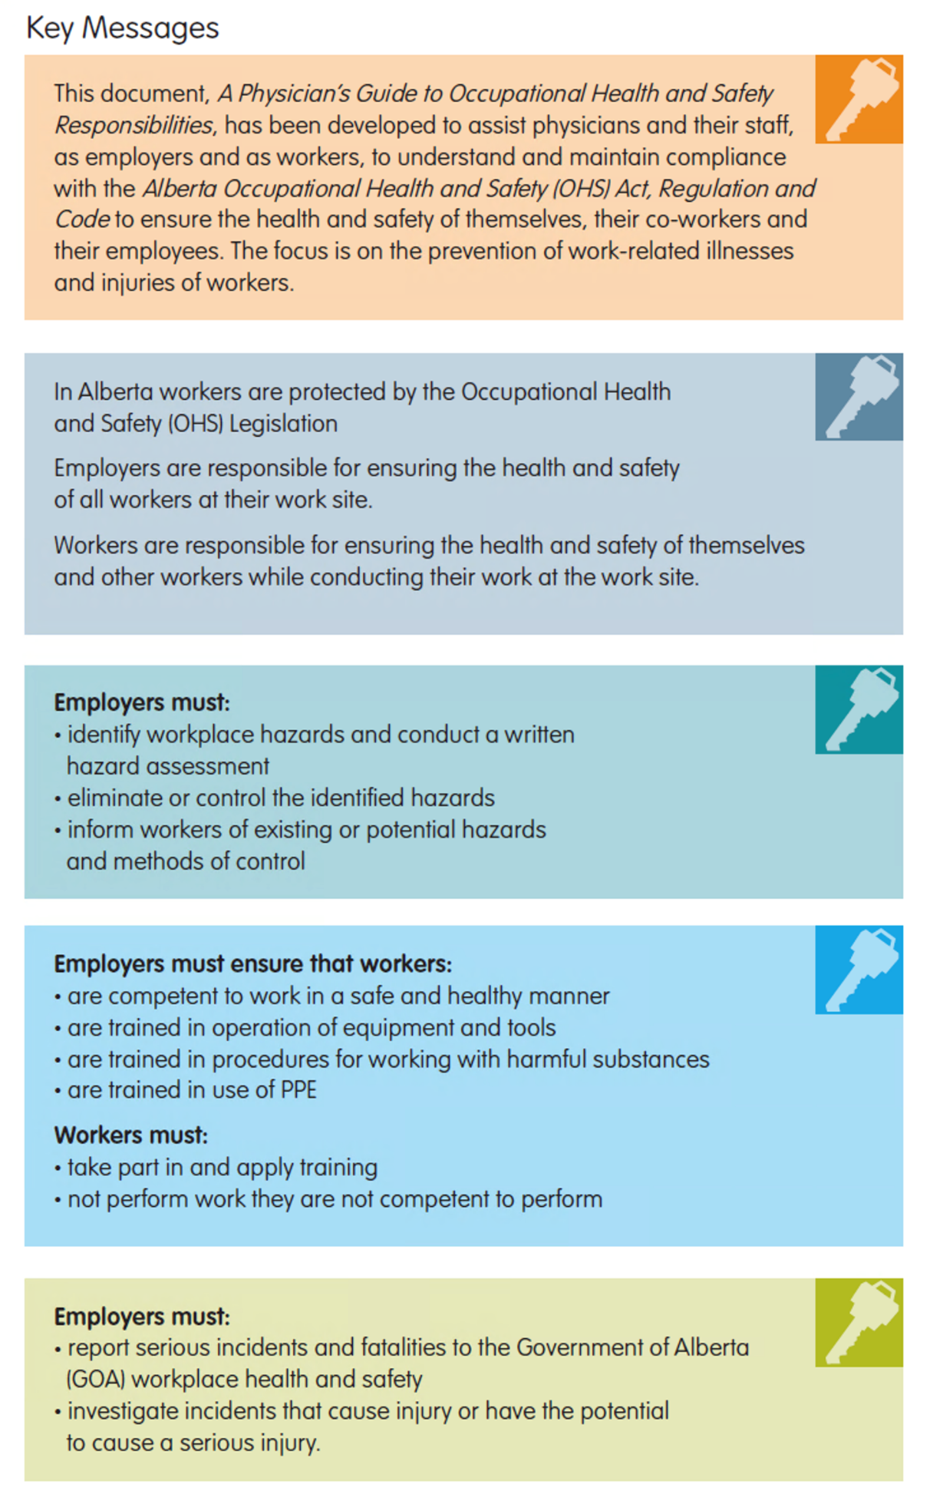
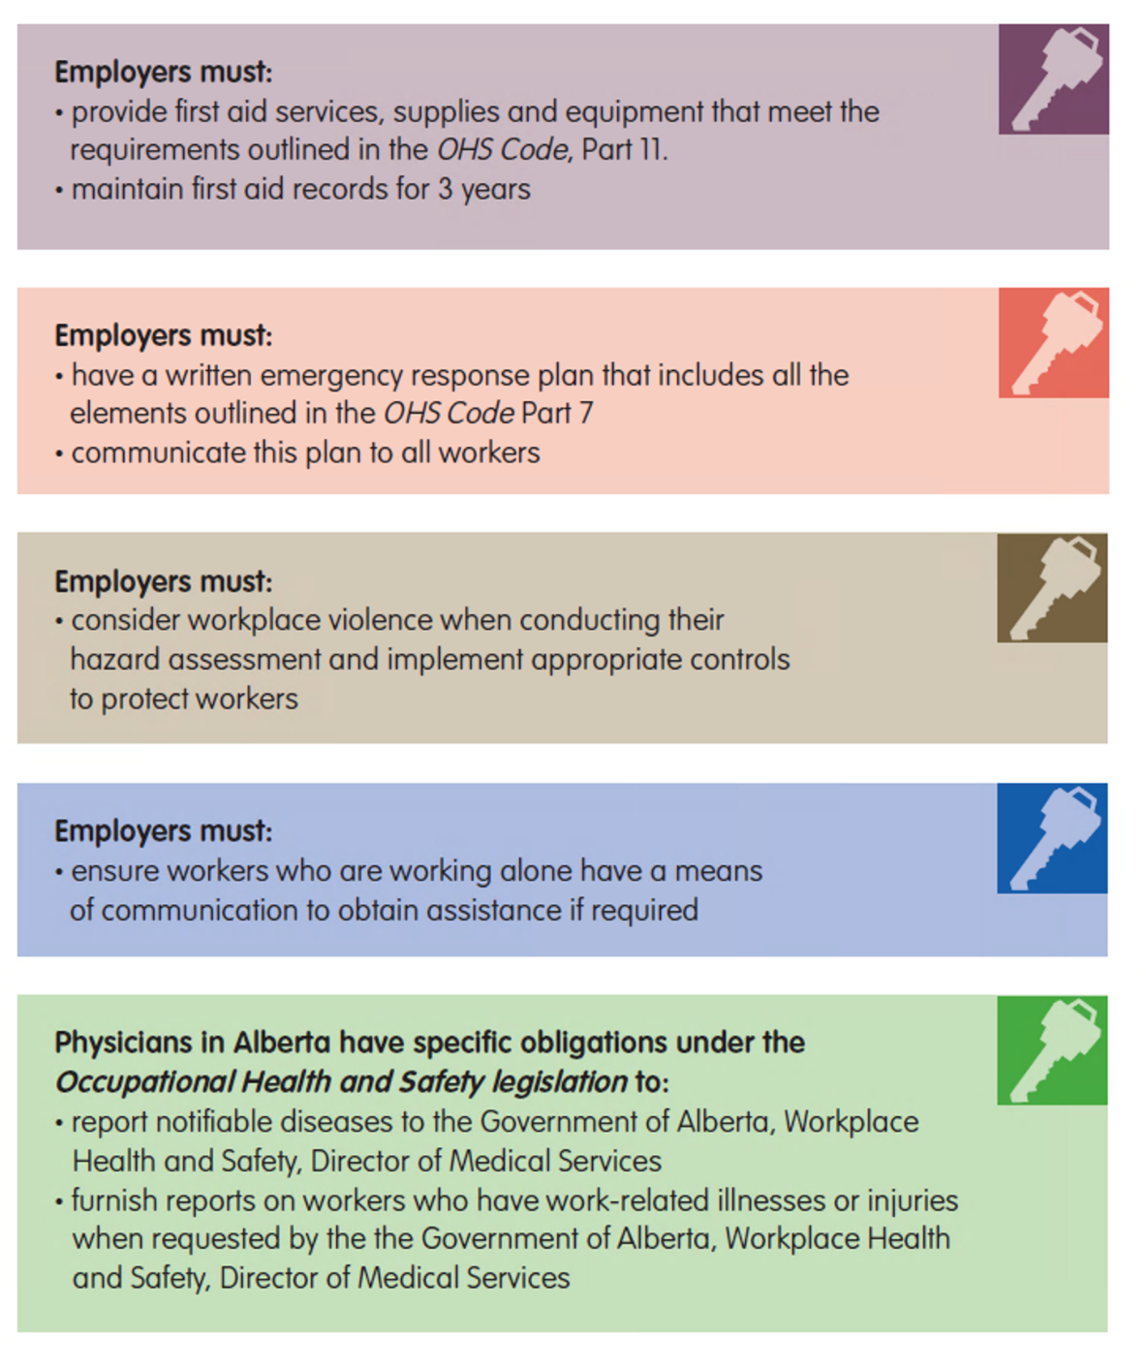

Sample Hazard Assessment Form
Step 1: On the Hazard Identification checklist, check off all the hazards or potential hazards that are present at your work site. Add any identified hazards specific to your work site to the list:
Hazard Identification
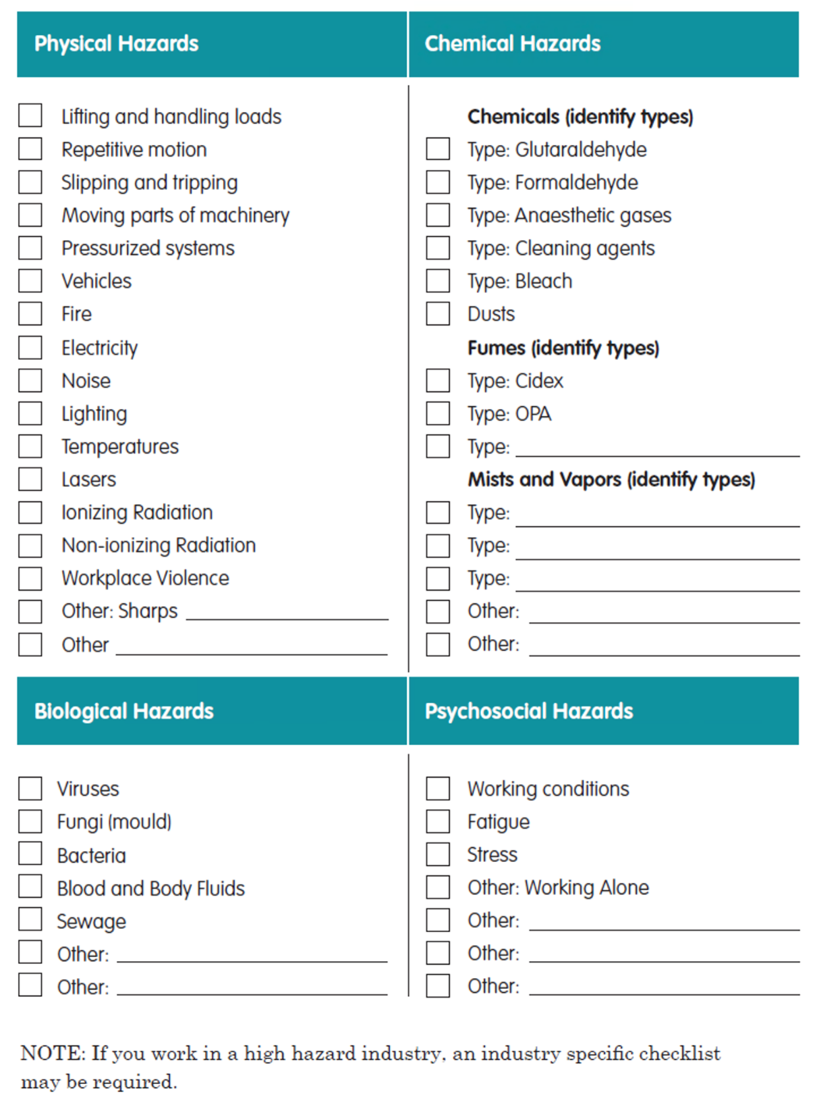

Step 2: Hazard Assessment and Control Sheet (Sample – Page 2)

- Take the hazards identified on the checklist above and list them on the Hazard Assessment and Control Sheet

- Identify the controls that are in place: engineering, administrative, PPE or combination for each hazard

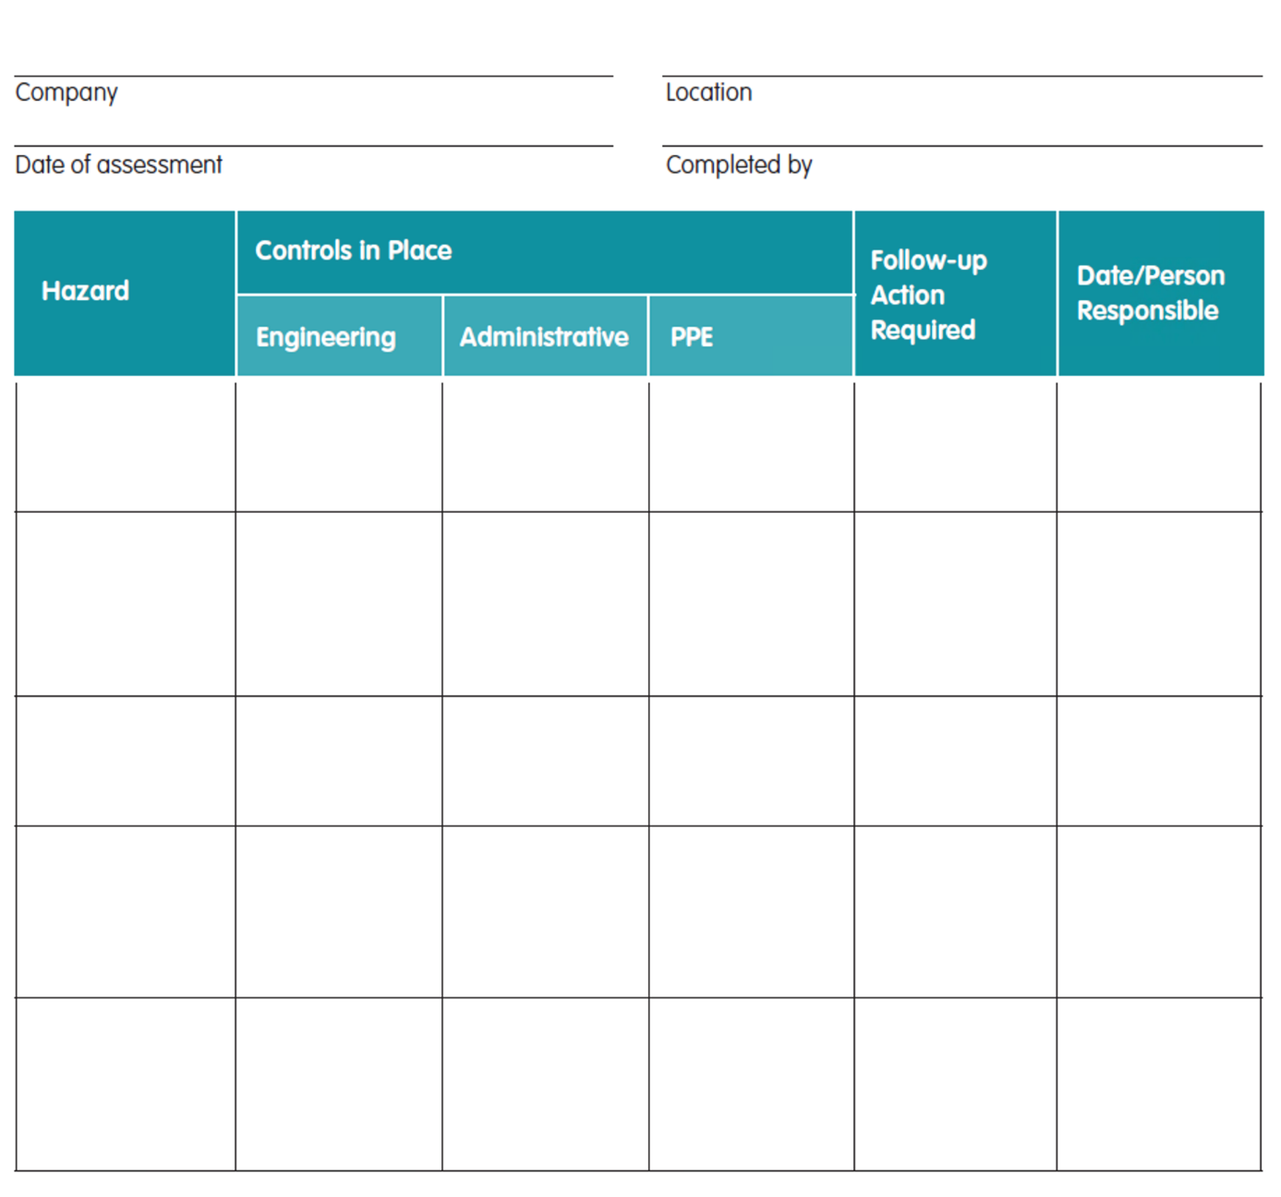

Sample Worker Orientation Record
This is an example of a checklist you may wish to use when training new workers on health and safety in your workplace.
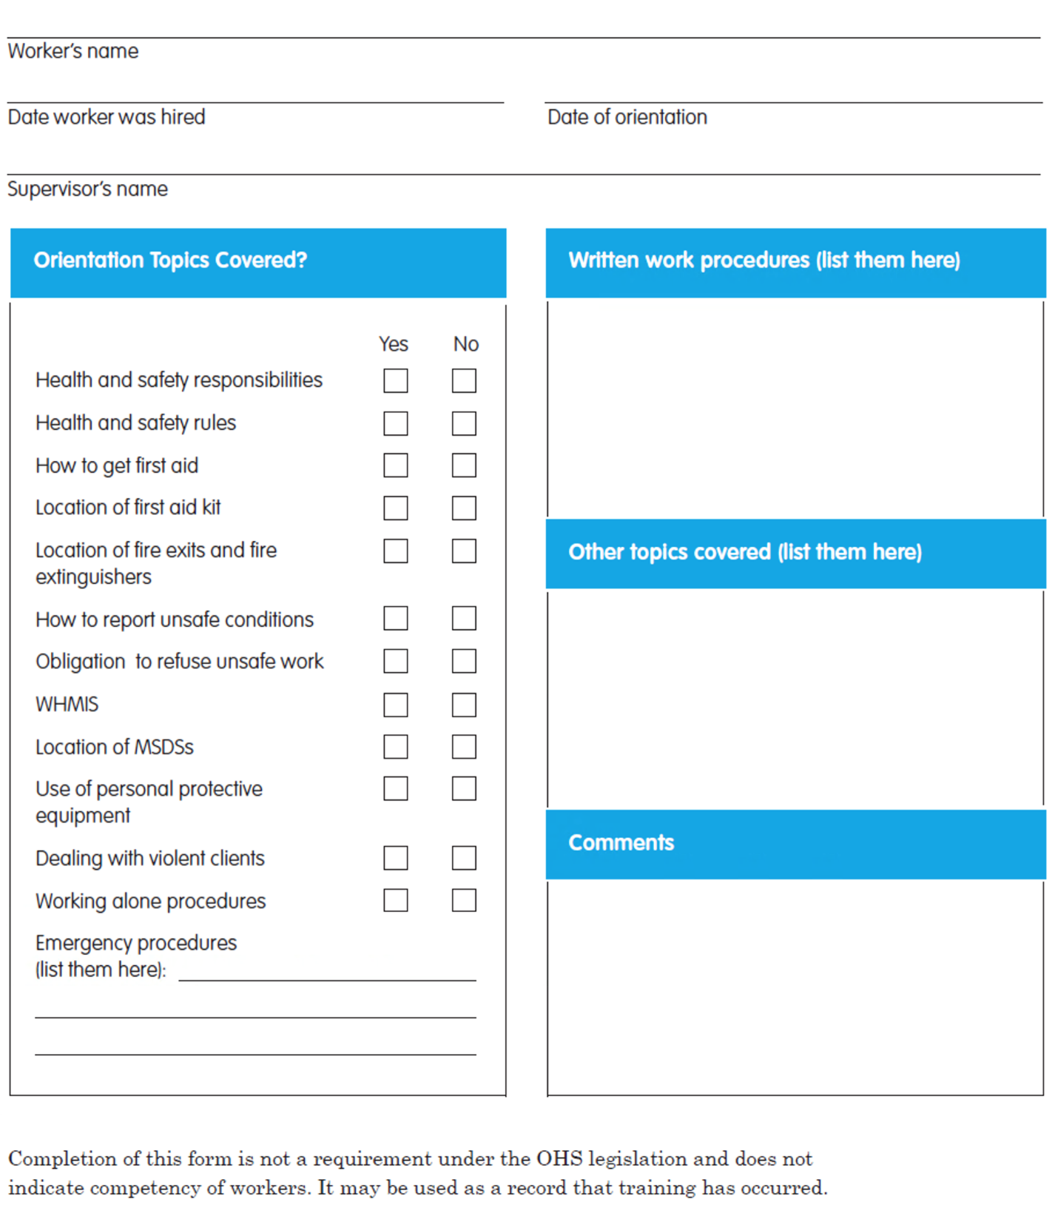

Sample Record of Training
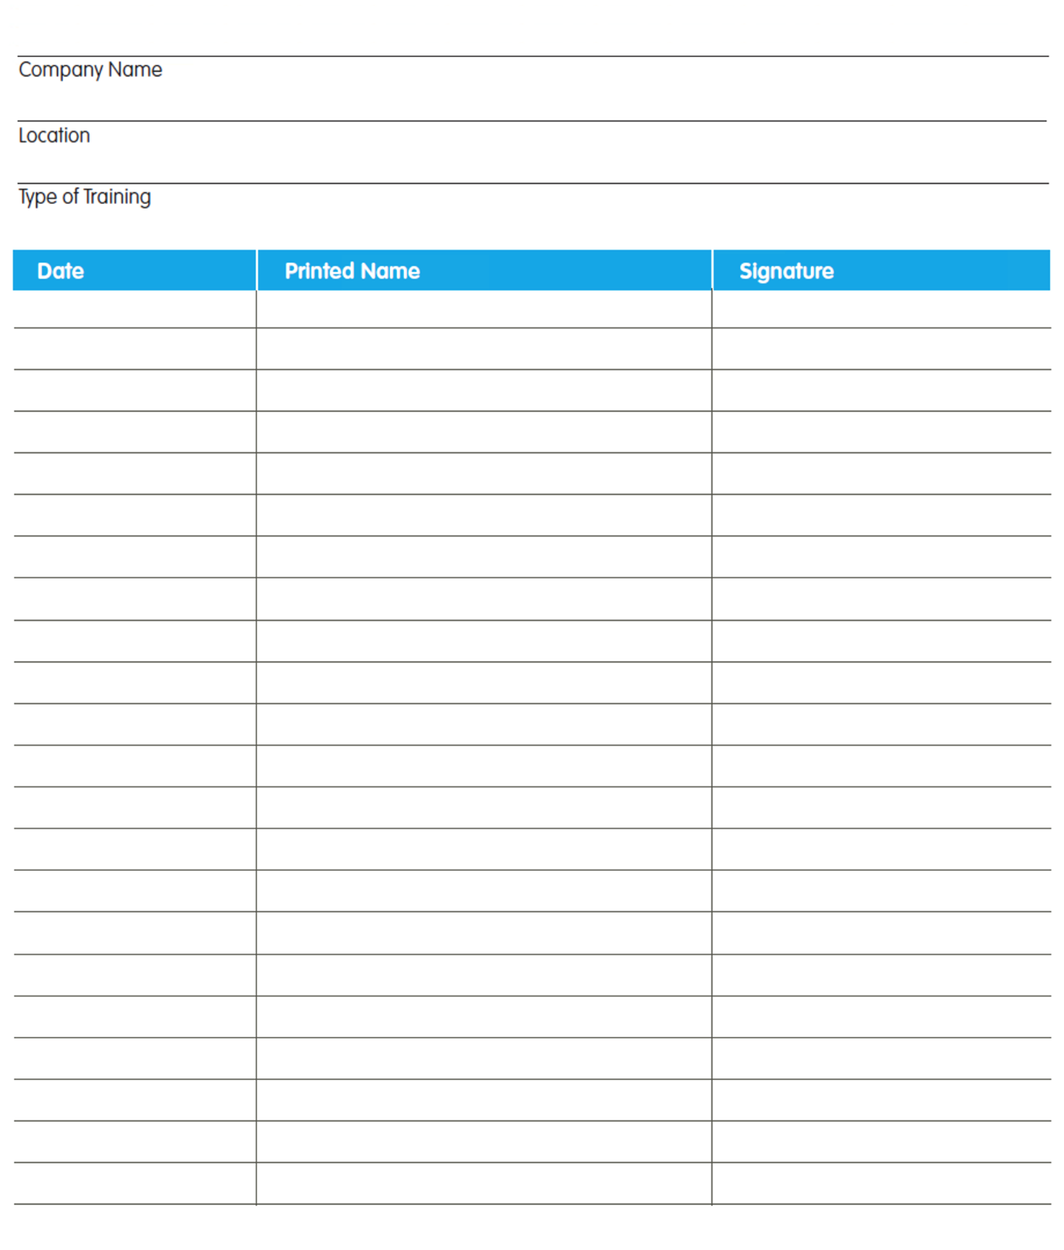

Sample Incident Reporting and Investigation Form
Use this report to record the results of your Incident investigation.
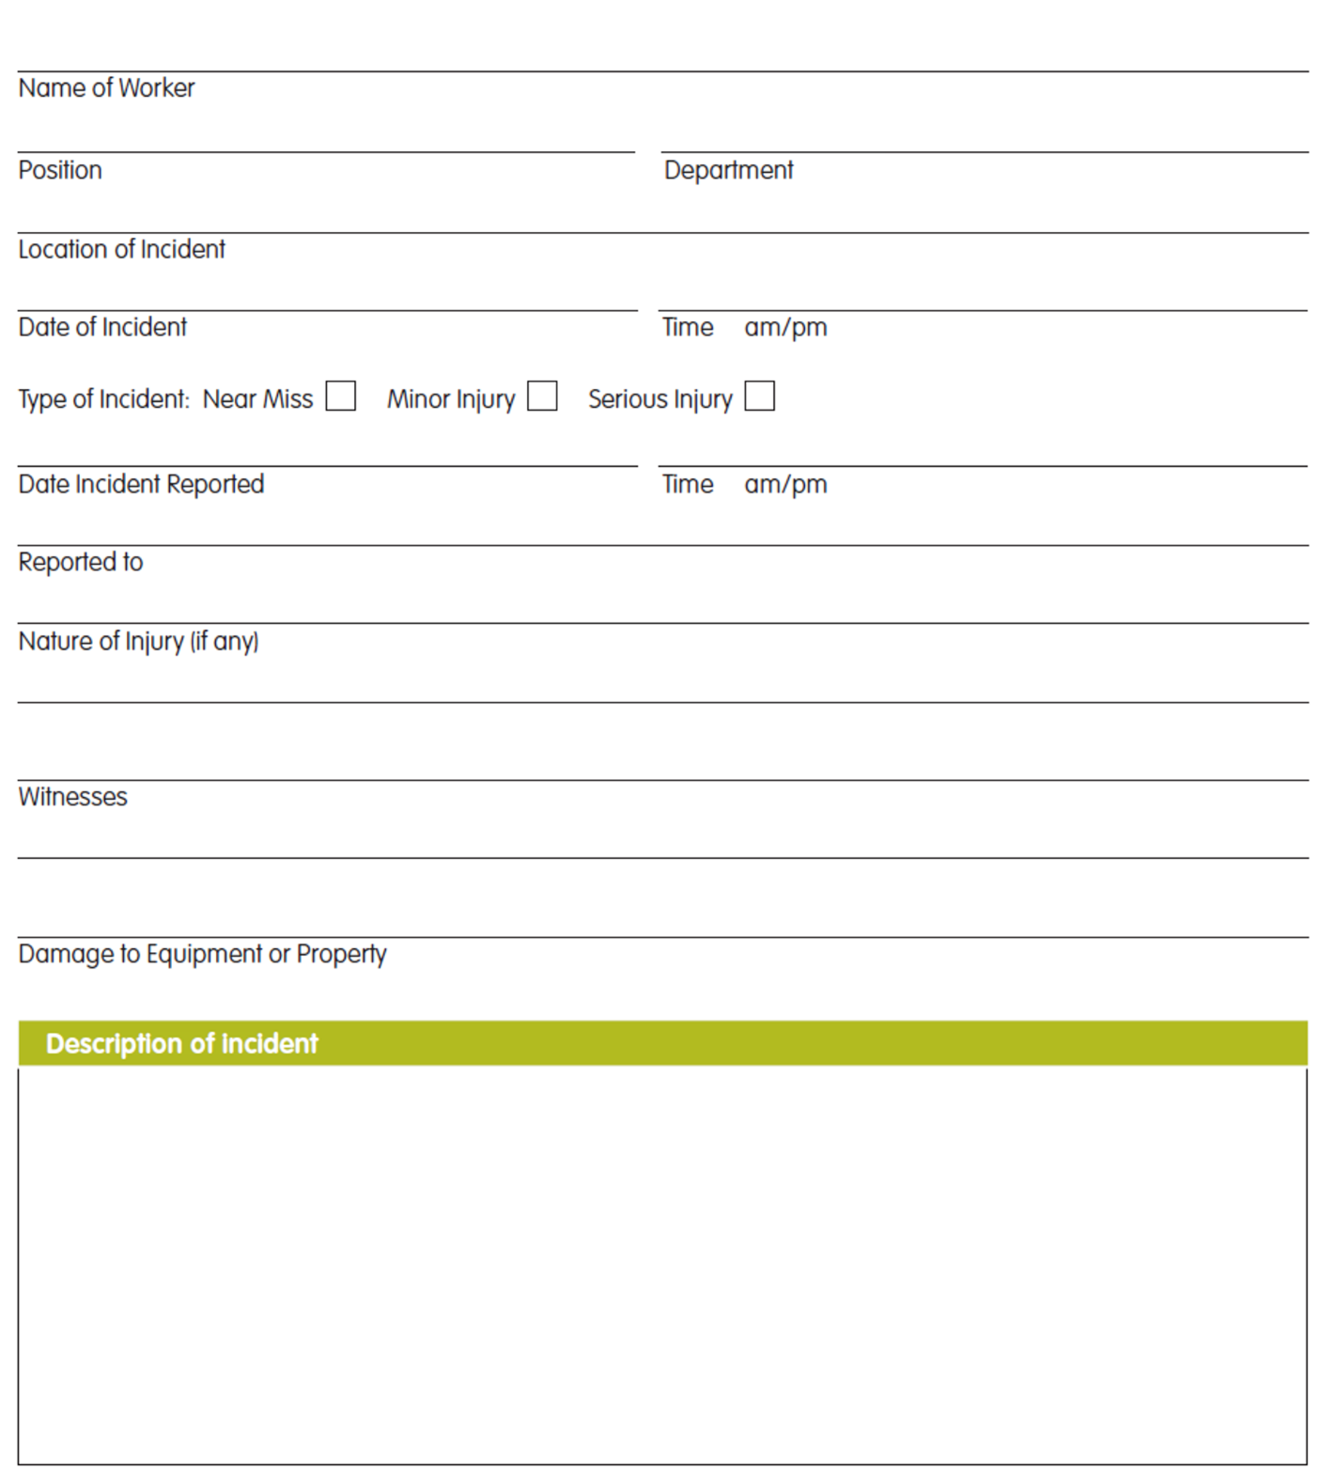

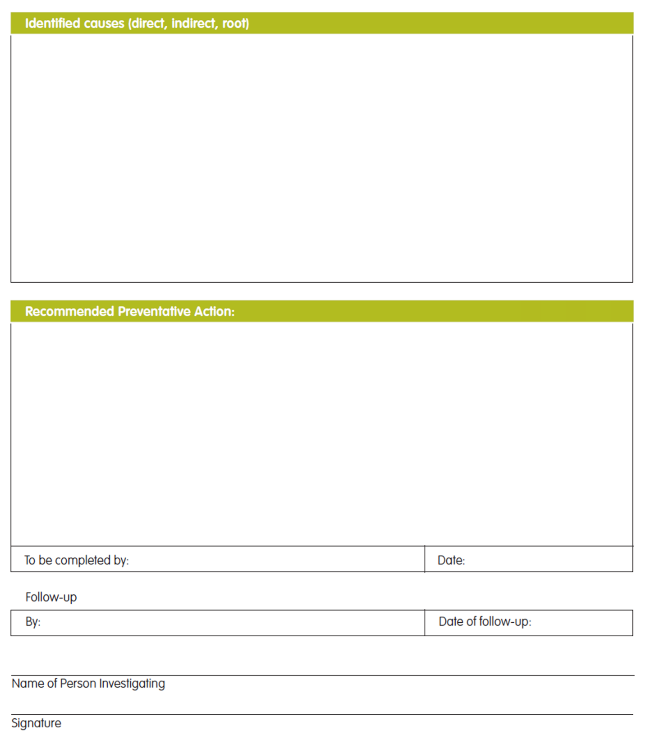

Sample First Aid Record Form
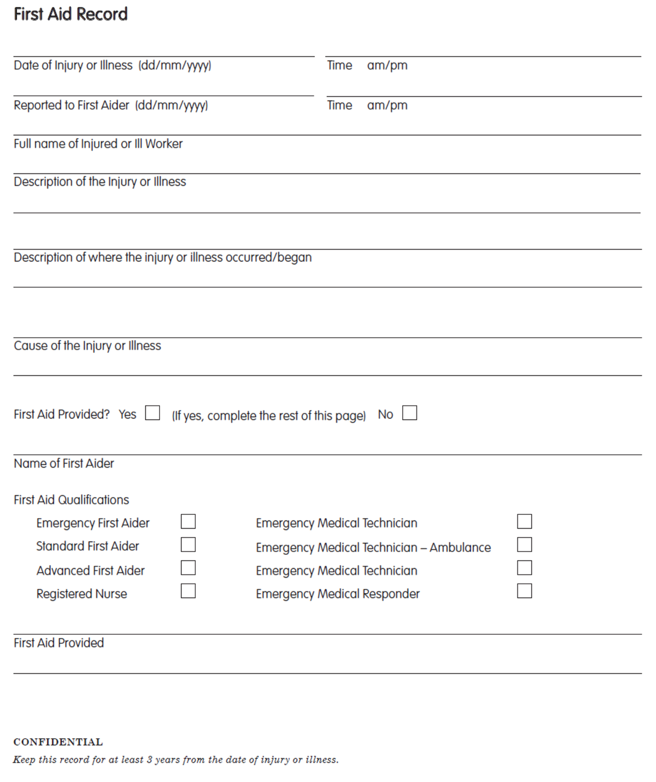

Sample Emergency Response Plan
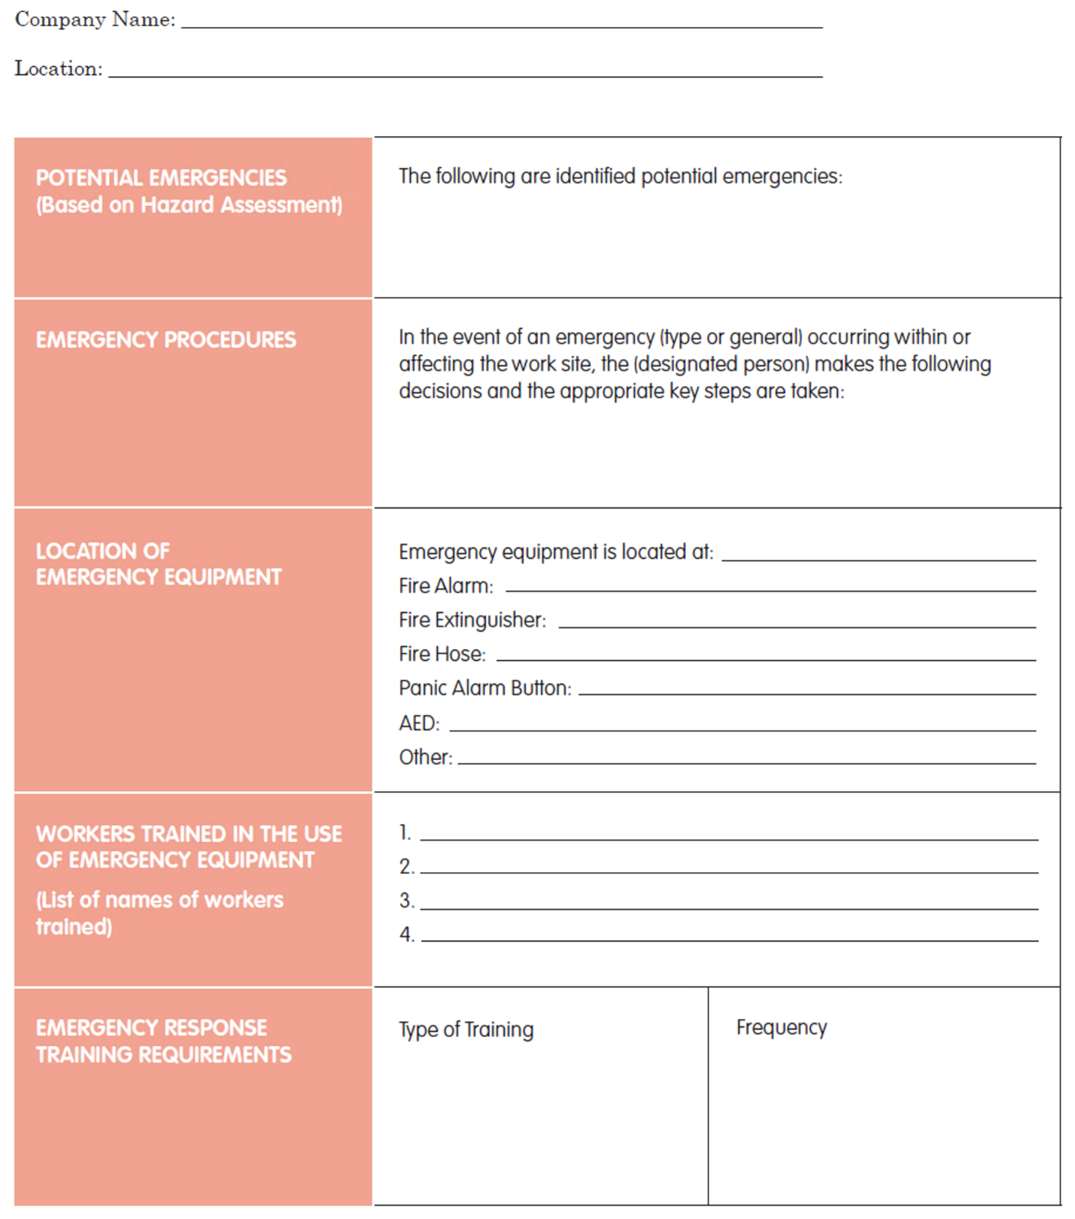

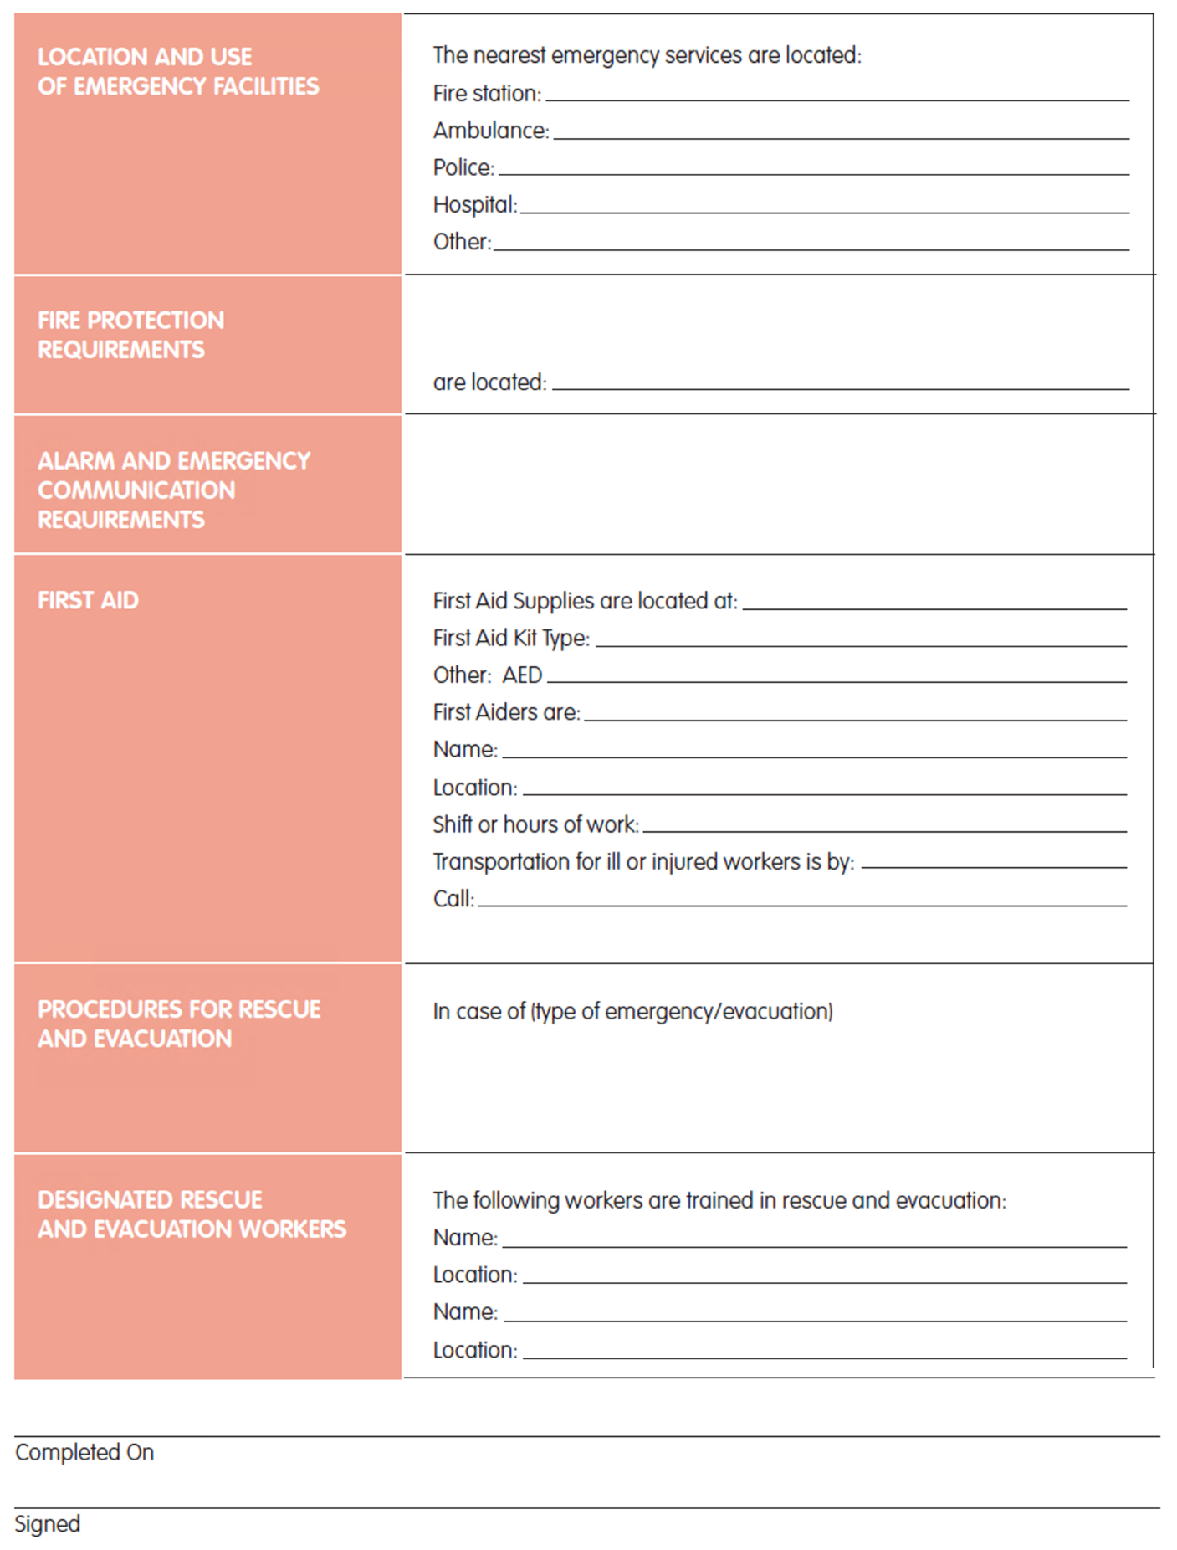

Sample Workplace Violence Policy and Procedures
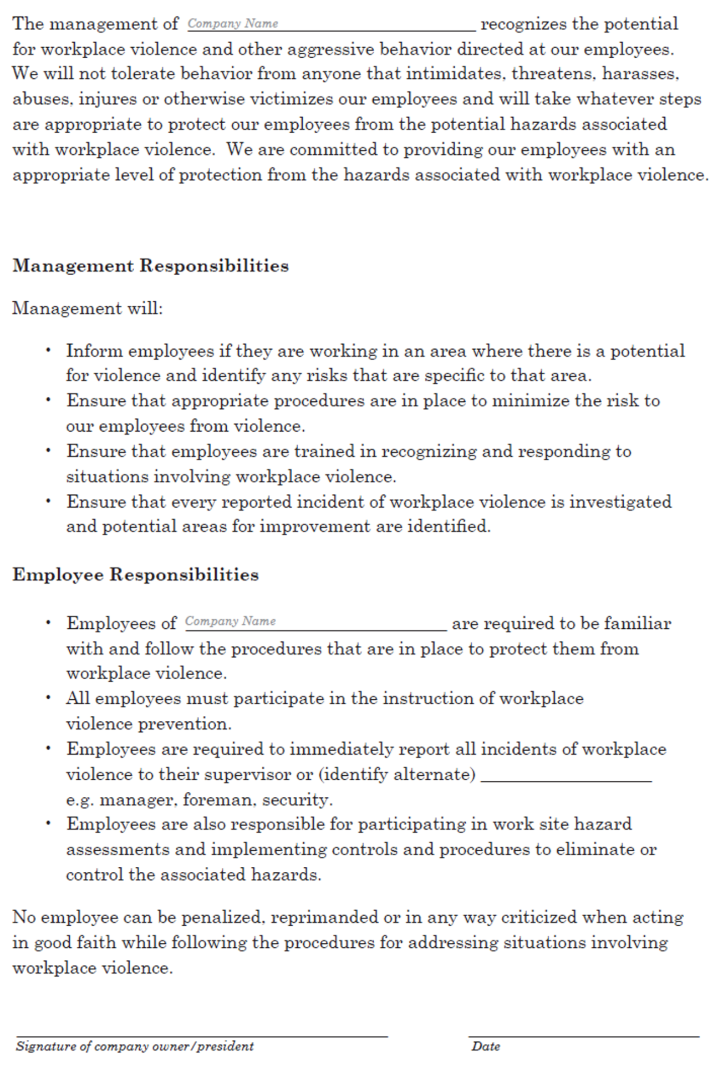

Procedures
In addition to a policy, procedures should be developed and communicated to all workers. The procedures should address the following areas:

- How potential hazards will be identified and communicated to staff.
- How to respond to workplace violence.
- How to report workplace violence.
- How to investigate and document incidents of workplace violence.
- The support available for victims of workplace violence.
- Training of workers.

EXAMPLE

APPENDIX I – MIFU Cleaning, Care, Maintenance and Sterilization - Specific Dental Instruments Examples Only

EXAMPLES ONLY

Each dental office should be aware of and follow the manufacturer’s instructions for the cleaning, care, maintenance and sterilization of the specific dental instruments used.

EXAMPLE

Cleaning and Sterilization of Rim-Lock Impression Trays

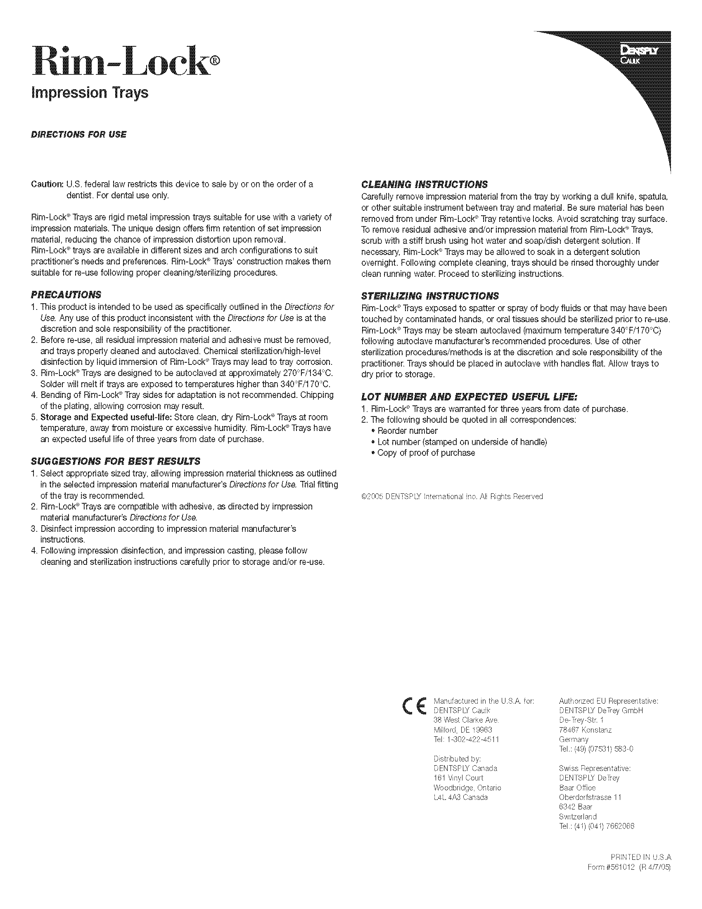

EXAMPLE

Care and Maintenance of Hu-Friedy Dental Instruments

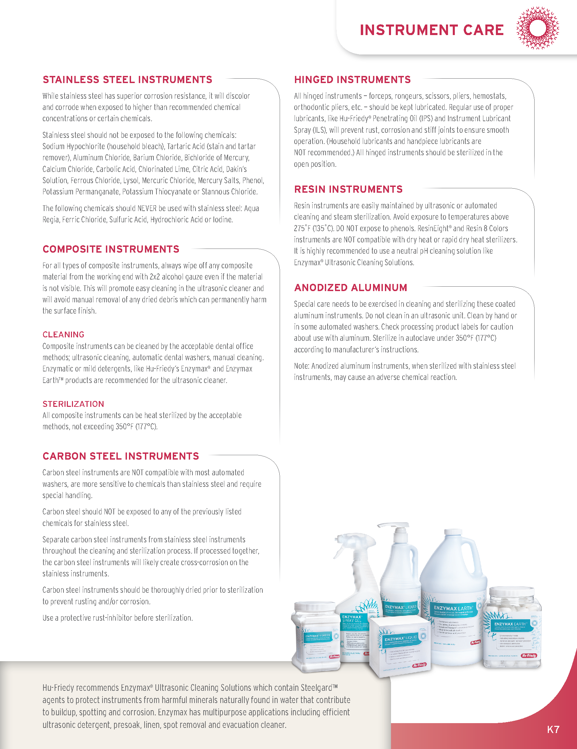
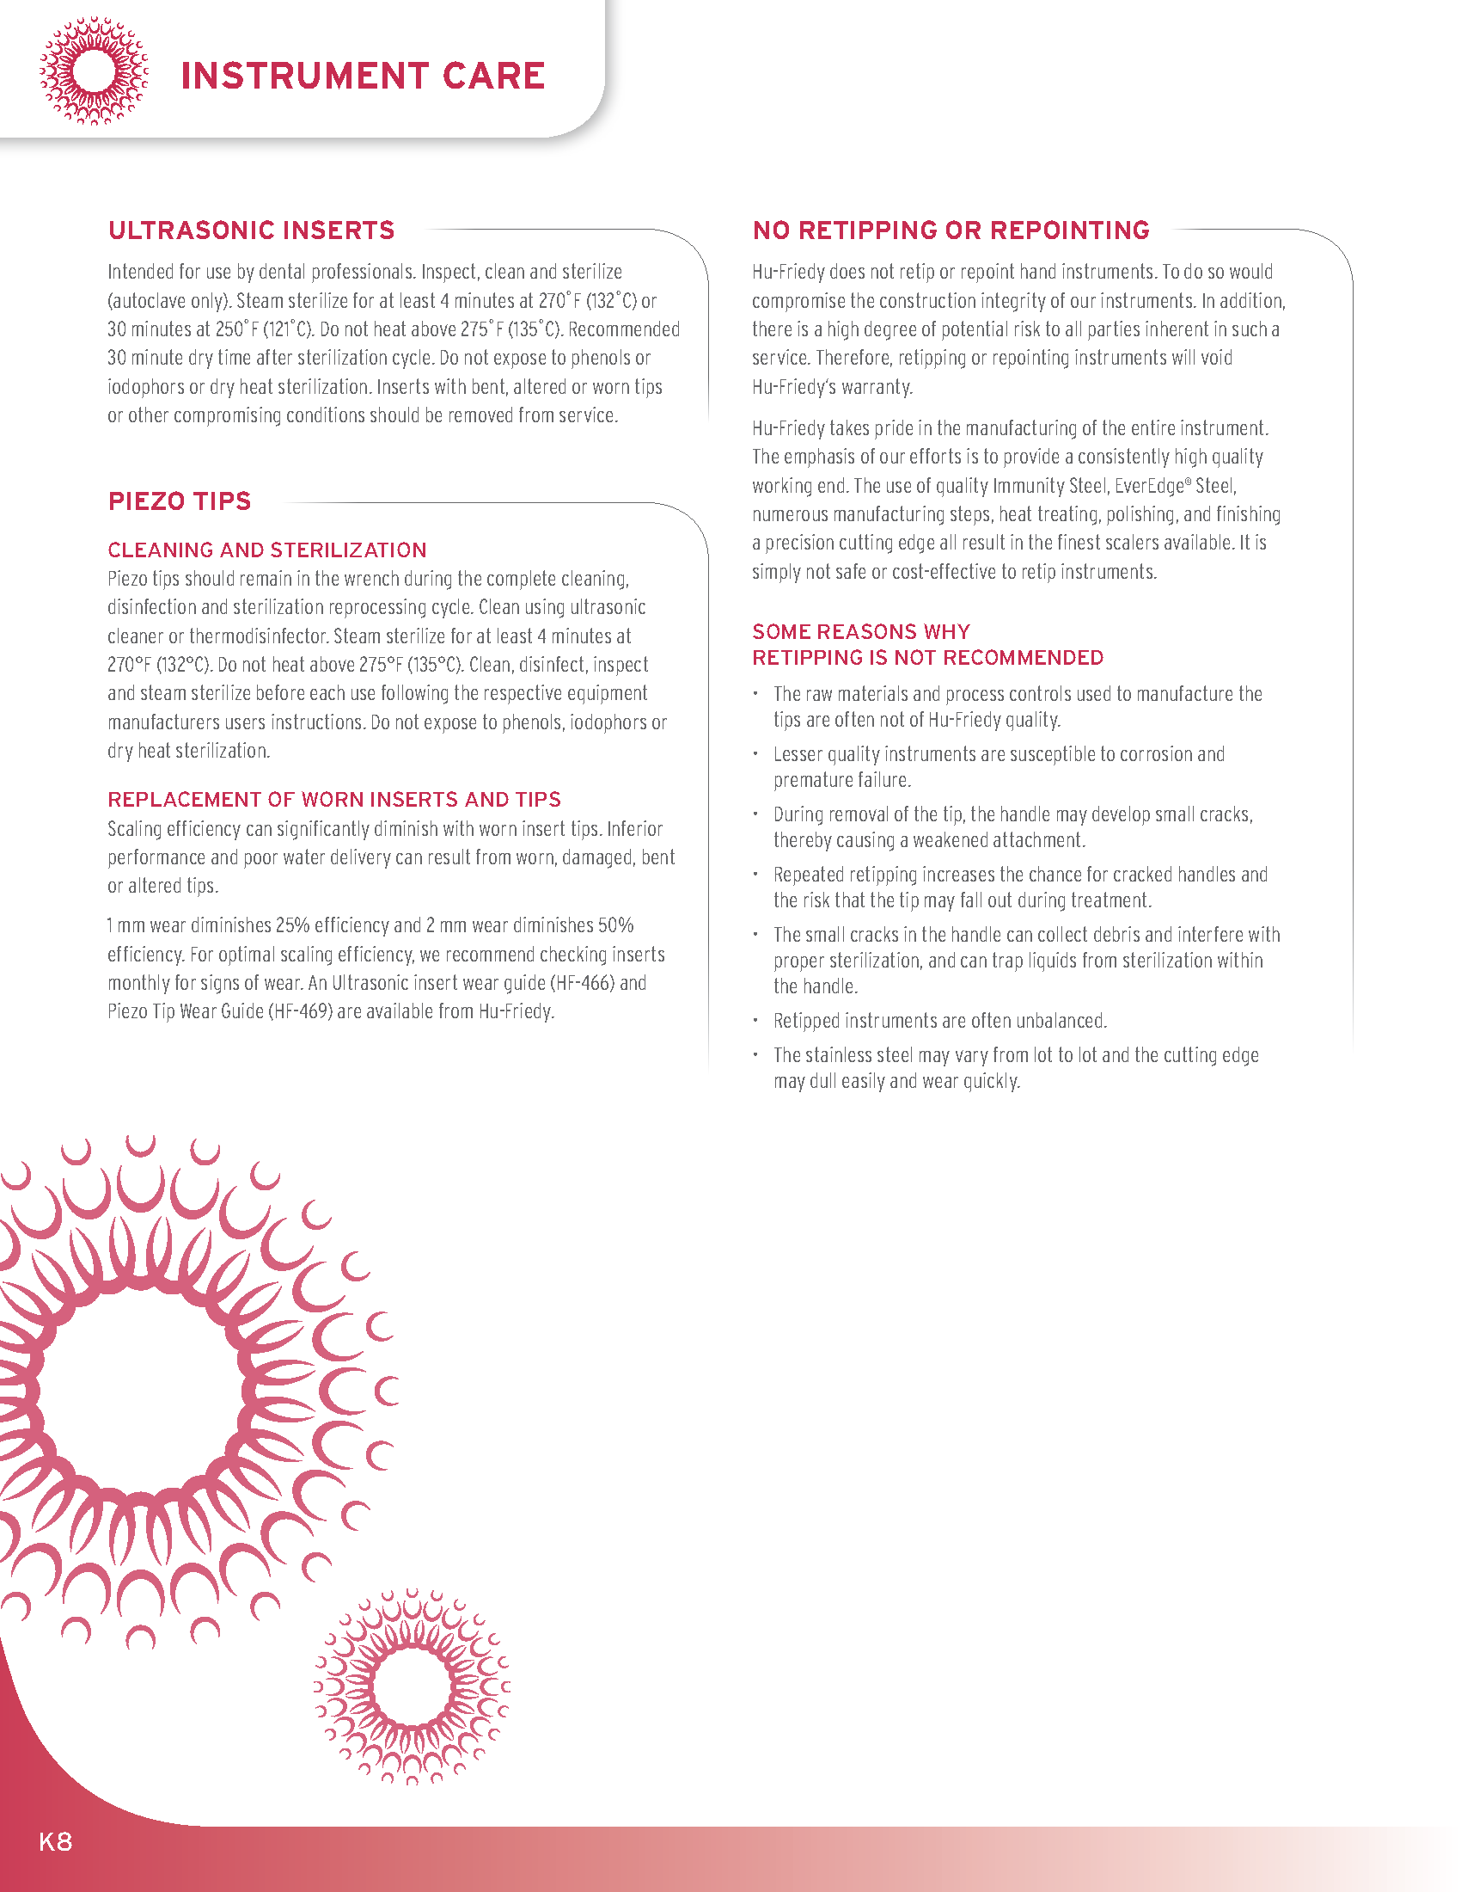
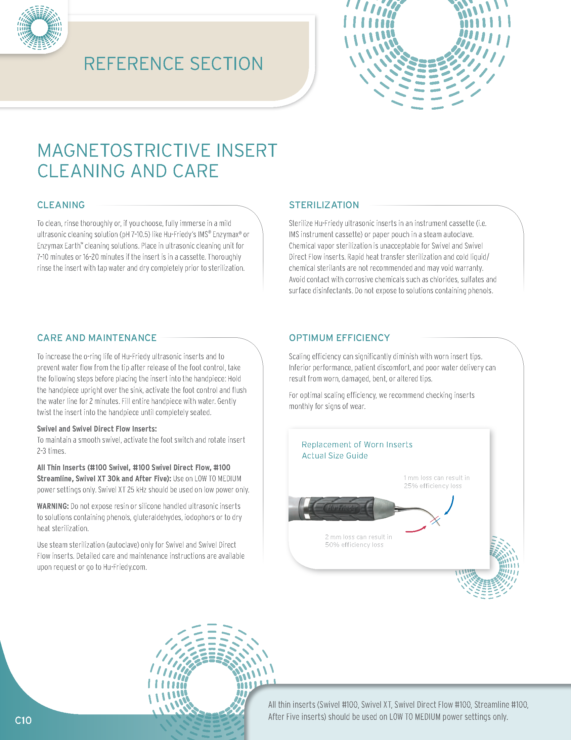
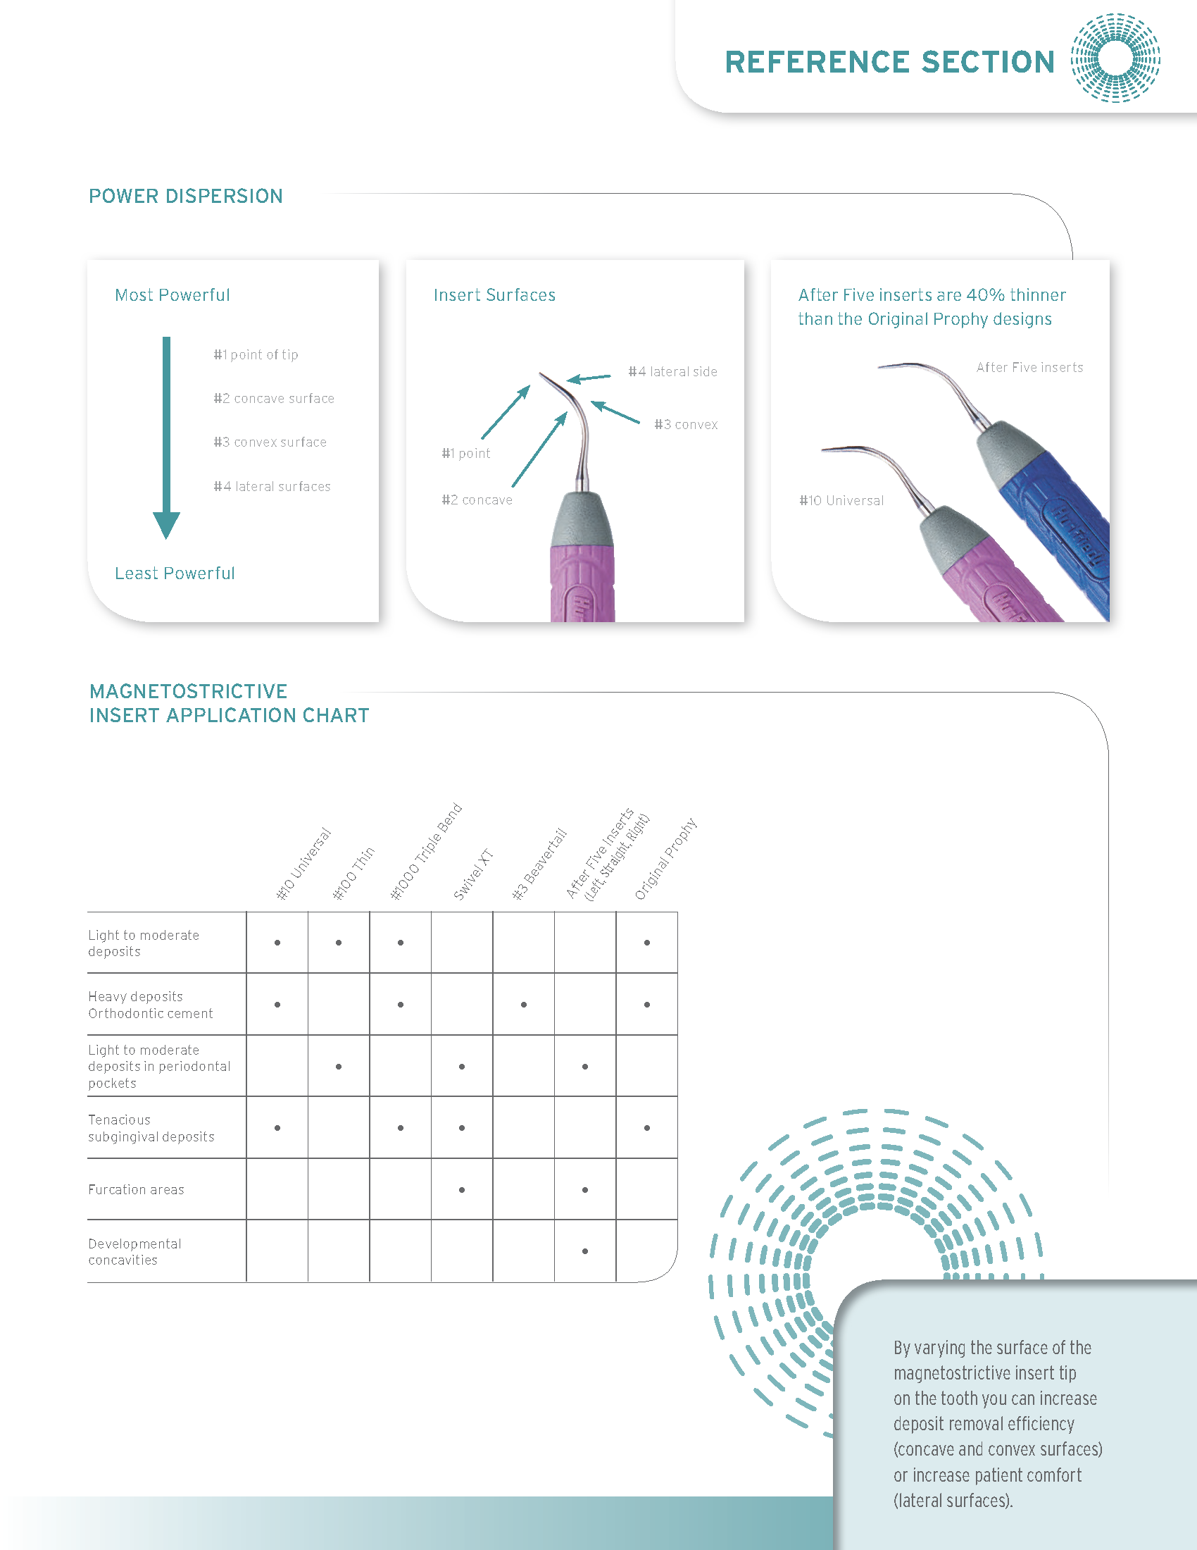
EXAMPLE

Special Procedures for Specific Hu-Friedy Instruments

Special Procedures for Specific Hu-Friedy Instruments

Aluminum Instruments | Cleaning: need special care. Use neutral cleaning agents suitable for Aluminum. Check cleaning agent label for precautions for use with Aluminum. Do not clean in an ultrasonic cleaner. Clean by hand or in an automated washer disinfector.  Processing: Note: Anodized aluminum instruments, when processed with Stainless Steel instruments may cause an adverse chemical reaction.
Amalgam Carriers | Maintenance after Use: Fully depress the lever, expelling unused amalgam. Submerge the barrel in isopropyl rubbing alcohol for 30 seconds and work the lever several times. All amalgam residues have to be removed.  Special instructions if Amalgam is hardened in the Amalgam Carrier:  If the above-mentioned measures fail to free the amalgam, grasp the barrel and gently twist it. Never apply any part of the carrier into a flame as this distorts the alignment of the instrument, tempers the metal and releases small amounts of vaporized mercury from the amalgam into the atmosphere.  Cleaning: Automated cleaning in an automated washer disinfector is recommended. Do not use chemical disinfection (cold sterilization); these chemicals may damage the Amalgam Carrier. After the cleaning apply a lubricant (recommended lubricant: Hu-Friedy ILS).  Sterilization: For sterilization use steam sterilization (gravity or fractioned vacuum procedure) only.
Aspirators and Aspirator Tips | Processing: Clean and sterilize only in a completely disassembled state.  Cleaning: For automated cleaning in an automated washer disinfector connecting rinsing adapters have to be used, if the inserts are processed inside a cassette system. Otherwise open tray systems for automated cleaning or manual cleaning is recommended (no Ultrasonic cleaning!).
Burs, Drills  Diamond Coated Burs – Special Instructions | Processing: We recommend the use of a bur stand for reprocessing (i.e. IMS-1372S or IMS-1372T also available in Trephines half size. For further information see the Hu-Friedy IMS-Catalogue).  Cleaning: In a suitable bur stand the burs, drills and trephines can also be reprocessed in an automated washer disinfector if they are not single use only products. Pre-treatment should be conducted outside of the bur stands.  Deterioration can rapidly occur on the bur cutting surface even after one single use and/or repeated re-processing cycles. Evaluate each bur prior to use for wear. Burs that are worn out will not cut efficiently and may generate excessive heat, vibration, and require the use of excessive force. Visually inspect burs for particle build up and/or debris. Remove all contaminants from the bur surface prior to sterilization; if necessary, mechanically clean using a nylon brush. Do not allow the burs to touch each other during cleaning. Corroded, worn out, and/or damaged burs should be discarded. Re-use of burs is at the sole discretion of the end user. Reprocessing of diamond burs should be validated by the end user facility in accordance with local laws and regulations.
Crown Remover (CRL and CRU) | Cleaning: Do not disinfect with phenols or iodophors.  Sterilization: Do not sterilize with dry heat.
Plastic Retractors (CRPC and CRPA) | Cleaning: Can only be disinfected by chemical disinfection. Do not clean/disinfect in an automated washer or washer disinfector.  Sterilization: Do not sterilize (steam, dry heat etc.)!
Carbon Steel Instruments | Processing: Clean and sterilize separately. Do not clean or sterilize with other stainless- steel instruments. Do not clean in an automated washer disinfector. After cleaning and prior to sterilization, use a proclave emulsion.
Chu’s Aesthetic Tool Kit Tips | Processing: Clean and sterilize with tip and handle disassembled. The tip will last for approximately 5 reprocessing cycles. Tips with fading markings should be replaced. Do not disinfect with phenols or iodophors. Do not use dry heat.
Colorvue | Processing: Clean and sterilize with tip and handle disassembled. The tip is disposable and will last about 30 reprocessing cycles. Tips with a fading black marking should be replaced. Do not disinfect with phenols or iodophors. Do not use dry heat or rapid heat sterilization.
Hinged Instruments | Processing: Process in an open state and lubricate prior to sterilization.
IMPLACARE | Sterilization: IMPLACARE disposable resin tips can be steam sterilized prior to use. They are intended for one use only!
360 Knife (K360) | Processing: Clean, disinfect and sterilize with fixation screw unscrewed.
MGA/MGC/MGI | Processing: When using a cassette system for cleaning/sterilization, the opening where the nylon tubing slips over the instrument tip must not be covered so as to allow the tips to properly drain. If the mouth gag does not fit in an available cassette, please contact Hu-Friedy for help finding the proper cassette size.
Mouth Mirrors | Processing: To avoid scratches on the mirror surface from other pointed instruments, reprocess in an appropriate accessory such as a parts box or clip in a cassette. Clean and sterilize in a completely disassembled state.
O-Rings | Sterilization: O-Rings cannot be dry heat sterilized.
Ortho-Instruments | Cleaning: Are not recommended to be cleaned in an automated washer.  Sterilization: The use of Steam Sterilization is recommended.
Osteotomes and Osteotom Handles | Processing: Clean and sterilize in a completely disassembled state if applicable.
Composite/Plastic Filling Instruments | Processing: Process in cassettes or trays with instrument rails to avoid scratches on the surface from other pointed instruments.  Maintenance: Residues of Filling Materials and Etching products must be removed immediately. Plastic Filling Instruments are designed with an extra smooth surface, in order to provide a better handling with composite materials. Scratches that are not visible might cause composite materials to stick to the rougher surface.
Resin Instruments and Resin Components or Resin Cassettes | Cleaning: For resin or silicone products do not use detergents or disinfectants containing phenols or iodophors.  Sterilization: Dry Heat is explicitly not compatible with Instruments with resin handles (handle #8 and C8), with resin or Silicone components such as cassette rails, instrument rings or grips, inserts on any instruments, or with resin cassettes. The sterilizer equipment manufacturer´s compatibility with specific materials must be observed.
Retractors | Processing: Removable retractor tips must be disassembled from the handle before cleaning and sterilization.
Root Canal Instruments | Processing: Reprocess in suitable endodontic stands (i.e. Hu- Friedy IMS-1275).  Cleaning: Pre-treatment should be conducted outside the Endodontic stand. Automated cleaning in an automated washer disinfector is recommended. Ultrasonic cleaning in the Endodontic stand is not recommended.
Syringes all types | Processing: Completely disassemble including unscrewing of the cylinder.
Ultrasonic Inserts Magnetostrictive | Processing: Ultrasonic cleaning and disinfection as well as steam sterilization can be affected in suitable Hu-Friedy IMS- Cassettes.  Cleaning: For automated cleaning in an automated washer disinfector consult dental instrument washer/disinfector user manual and/or manufacturer.  Sterilization: For sterilization use steam sterilization (gravity or fractioned vacuum procedure) only. Do not expose to phenols or iodophors, do not use dry heat sterilization, or heat above 135°C (275°F).
Ultrasonic Piezo Tips/ Wrench with Guardian | Processing: Piezo tips should remain in the wrench during the complete reprocessing cycle, also if reprocessed in cassettes.  Ultrasonic cleaning as well as steam sterilization can be affected in suitable Hu-Friedy IMS-Cassettes.  Use Wrench to include Guardian and the EMS Combitorque.  Sterilization: For sterilization use steam sterilization (gravity or fractioned vacuum procedure) only. Do not expose to phenols or iodophors, do not use dry heat sterilization, or heat above 135°C (275°F).
Ultrasonic Piezo Handpiece | Sterilization: The Piezo handpiece can be steam sterilized with all types of Steam Sterilizers at 273.2°F (134°C) for 15min. Other sterilization parameters are not permitted.
Oversize Instruments | Processing: If instruments do not fit in cassettes, other systems should be considered for reprocessing. Please call Hu-Friedy for assistance Tel 800-HU-FRIEDY.

EXAMPLE

Use and Care of Midwest Burs

EXAMPLE

Sterilization and Maintenance of Miltex Surgical Instruments

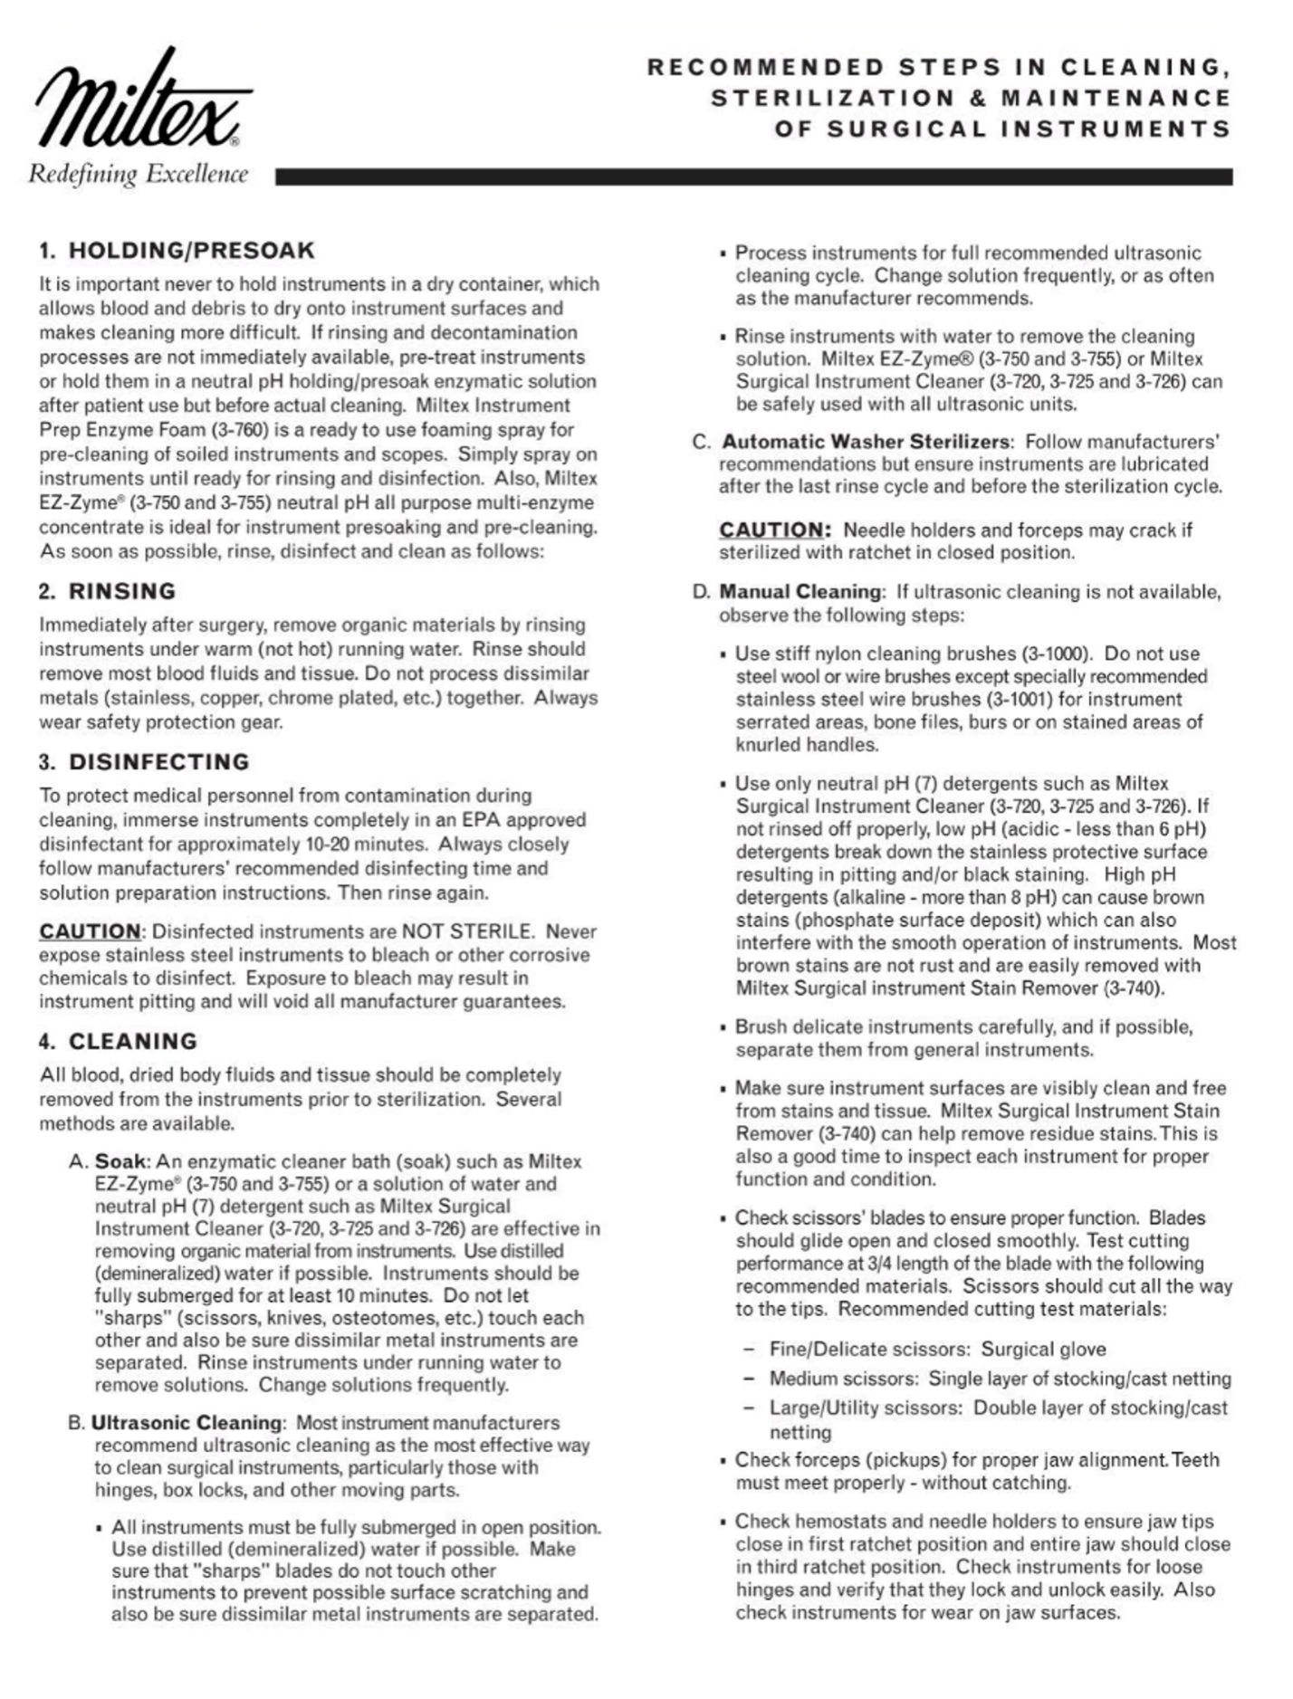
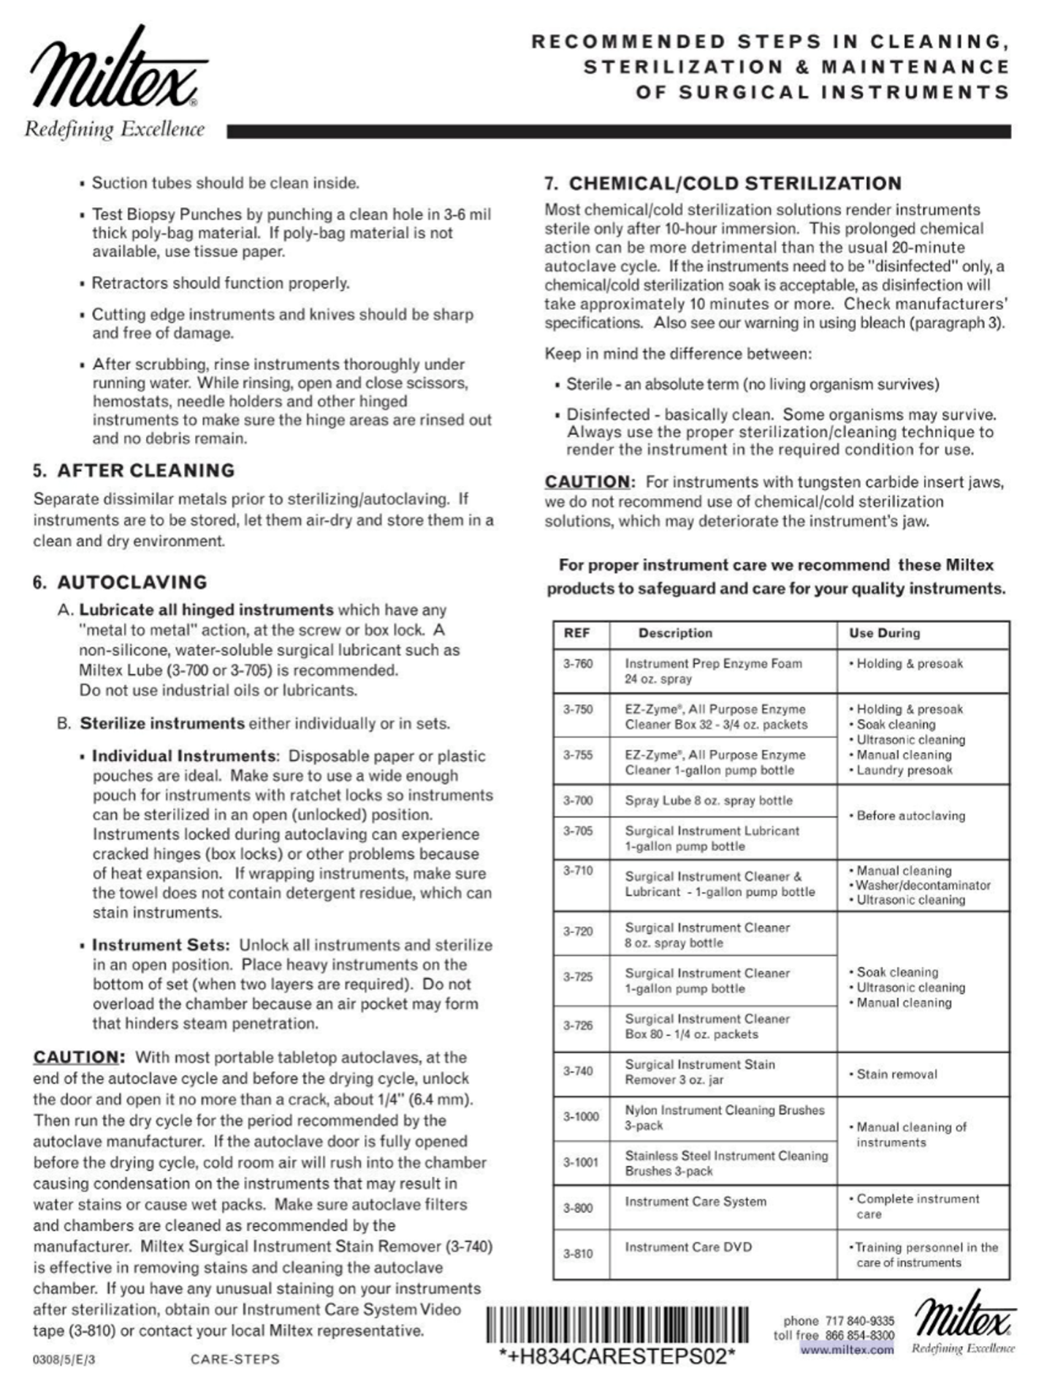
EXAMPLE

APPENDIX II – MIFU Care and Preventative Maintenance - Dental Equipment Examples Only

EXAMPLES ONLY

Each dental office should be aware of and follow the manufacturer’s instructions for the care and preventative maintenance of the dental equipment used.

Maintenance Schedule

VistaPure Ultra Pure Water System

Filter Replacement Record
HYDRIM® L110w

Hydrim Care and Maintenance
Replacing the HIP Cleaning Solution
The Hydrim L110w uses a 3.L/1 gallon container of Hip Cleaning Solution (Part number CS-HIPL). Use only the recommended cleaning solution and read the MSDS before inserting into the unit.

When the message “no detergent” appears on the screen, the cleaning solution container is empty and is in need of changing. To avoid spillage, replace the solution container only when the message appears and be sure to wear gloves.

NOTE: Each cleaning solution lasts approximately 30 cycles, depending on which cycles are used.

To replace the cleaning solution container, follow these steps:
- Turn the power switch OFF.
- Open the cleaning solution door,
- Disconnect the cleaning solution connector. Remove and dried chemical by immersing the connector in a cup of water.
- Remove the empty cleaning solution container and discard or recycle.
- Connect new container and insert into the cleaning solution compartment. Follow the instructions printed on each cleaning solution container.
- Close the door.
- Turn the power switch ON.

Refilling the Water Softening Salt Reservoir
When the error message “salt level low” appears, the salt reservoir is in need of refilling. Ensure that your local authorized technician has set the water softener according to the hardness level in your area.

To refill the salt reservoir, follow these steps:
- Unscrew the salt container lid.
- Fill the slat container to the top (maximum 1kg/2.2lbs.)
- Screw the salt container lid on tightly.
- Run a complete cycle, with no instruments.

Using the Rinse Aid
Rinse aid is not required when using the Hydrim L110w with HIP cleaning solution. There is a rinse-aid container in the Hydrim L110w, but it is not active and should not be filled.

Cleaning the Hydrim L110w
To clean the outer surfaces and decal covering the touch screen, use a soft cloth moistened with soap and water or a surface disinfectant. Do not use harsh cleaning chemicals.

If preparing the unit for transport or storage, wastewater should be removed from the sump.

Wastewater in the unit may contain biological contaminants. Use a mechanical means to siphon the contents. Wear disposable rubber gloves. Dispose of absorbent material according to biological waste disposal regulations.

Filter and Wash Arm Maintenance

Filter Maintenance
Inspect the filter in the bottom of the chamber daily for debris and clean id necessary. To clean, remove the filter and rinse under a tap and replace. Ensure that the filter is firmly locked into position when replaced.

Wash Arm Maintenance
If the wash arms are not turning easily, remove them, rinse under a tap and reassemble. To remove the upper or middle arm, unscrew the collar counter clockwise. To remove the lower arm, unscrew the collar clockwise.

Statim 2000 and 5000 Maintenance

DAC Universal

Mocom MillenniumB² Steam Sterilizer

Lisa Pre-Vacuum Sterilizer Maintenance
USER MAINTENANCE
A distinction must be made between two levels of maintenance, that performed regularly by the user and preventive maintenance carried out by an approved technician (§ 8).

Remove the mains cable before examining the sterilizer.

MAINTENANCE PROGRAM
Frequency / | N° of cycles | Operation | Spare number | Description
Weekly | 50 | Cleaning the door seal.  Cleaning the chamber, the trays and the rack.  Cleaning the external surfaces. | -  -  - | § 7.2.  § 7.3.  § 7.4.
Every 3 months | 400 | Replacing the bacteriological filter. | W322400X | § 7.5.
Every 6 months | 1000 | Cleaning both water tanks. | - | § 7.6.
Every year | 1000 | Replacing the door seal. | F460503X | § 7.7.
* Every 3 years. | 4000 | Servicing by an approved technician. | - | § 8.
*Refer to the legislation and instructions for each individual country.
The maintenance sub-menu (§ 4.5.7.) indicates the number of cycles remaining before replacement of the bacteriological filter, the door seal and when general servicing is required. The three counters are decreased in value after each cycle.
When one of the counters reaches 0 a corresponding message appears at the bottom of the selection screen.
It is not possible to run a new cycle (the selection button will disappear) unless the reading of the message has been confirmed by pushing the "OK" icon. The counter is then automatically reset.
If one of the three operations is completed before the respective counter has reached 0 it is necessary to reset the counter manually. Place the cursor in front of the operation with the icons UP and DOWN and reset it by pushing the "OK" icon.

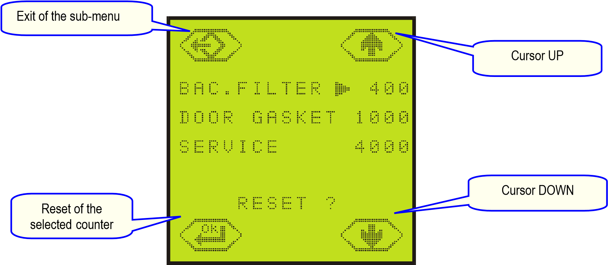
CLEANING THE DOOR SEAL
- Clean the door seal and the porthole with a lint free cloth saturated with alcohol.
- The porthole can also be cleaned with a non-abrasive detergent.
CLEANING THE CHAMBER, TRAYS AND TRAY HOLDER
- Remove the trays from the chamber.
- Disconnect and remove the rack.
- Clean the chamber with a damp sponge moistened with a detergent or scouring agent if necessary.
- Rinse with a damp sponge to remove all traces of the cleaning agent.
- Apply the same procedure for the rack, trays (cassettes).

- Ensure that you clean all around the sterilizer chamber.
- Do not bend or damage the temperature sensor at the bottom of the chamber.
- Never use disinfectants to clean the chamber.

CLEANING THE EXTERNAL PARTS
- Clean the external parts with a damp cloth and mild detergent.
- Never use scouring agents or highly abrasive products.

- Do not use copious amounts of water to wash the sterilizer as this may damage the electrical components and safety mechanisms.
- Take care not to scratch the plastic film in front of the touch-screen.

REPLACEMENT OF THE BACTERIOLOGICAL FILTER
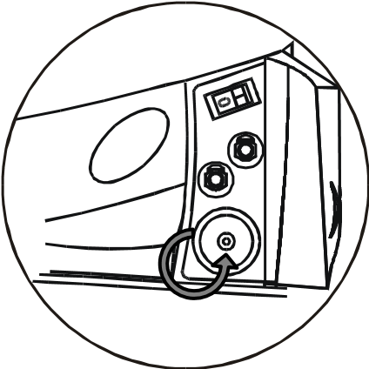
- Open the service door.
- Unscrew the bacteriological filter by hand (anti-clockwise).
- Insert and manually screw the new filter into position.

CLEANING THE WATER TANKS
Completely drain both water tanks (main and used water tank).

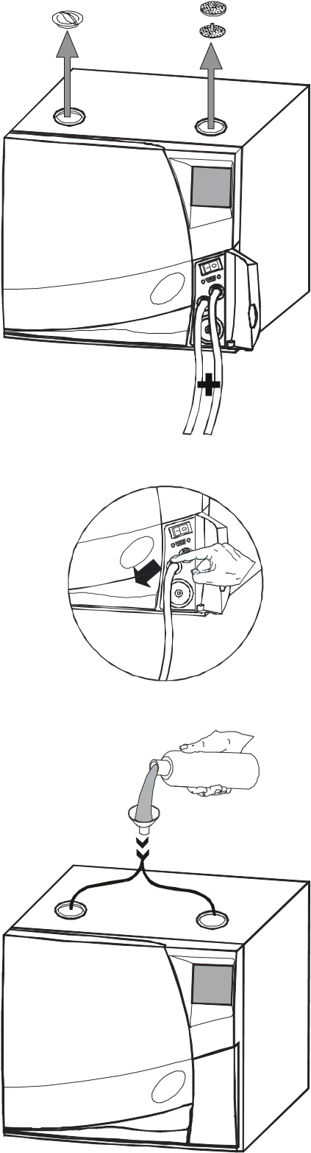
- Open the service door.
- Insert the drain tube into the quick coupling drain connection of the used water tank (right). Allow the entire contents of the tank to empty and discard the used water.
- Disconnect the drainage hose by pressing the push-button on the drain connection.

- Insert the drain tube into the quick coupling drain connection of the main water tank (left). Allow the entire contents of the tank to empty.
- Disconnect the drainage hose by pressing the push-button on the drain connection.

- Fill both reservoirs each with:
2.8 litres of demineralised water + 0.2 litres of 90% alcohol (MB17)
3.7 litres of demineralised water + 0.3 litres of 90% alcohol (MB22)

DO NOT RUN A CYCLE !

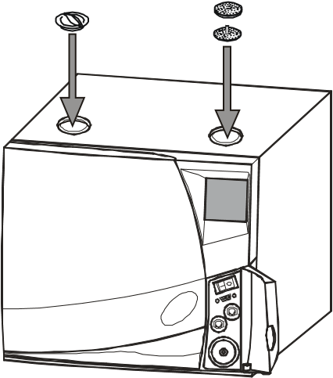
- Allow the solution to sit for 30 minutes.

- Drain both tanks and discard the 3 litres on MB17 (4 litres on MB22) of solution.
- Fill the main tank with 3 litres on MB17 (4 litres on MB22) of distilled or demineralised water.
- Run an empty cycle.

If the sterilizer is not used for more than 3 days, both water tanks must be completely drained in order to avoid alga growth or any other deposits.
REPLACING THE DOOR SEAL
- Fully open the door of the sterilizer.
- Remove the door seal by hand.
- Carefully clean the seal seat with a cotton bud moistened with alcohol.
- Moisten the new seal.
- Insert the seal in the sequence illustrated in the following diagrams:

Insert the seal starting as follows:

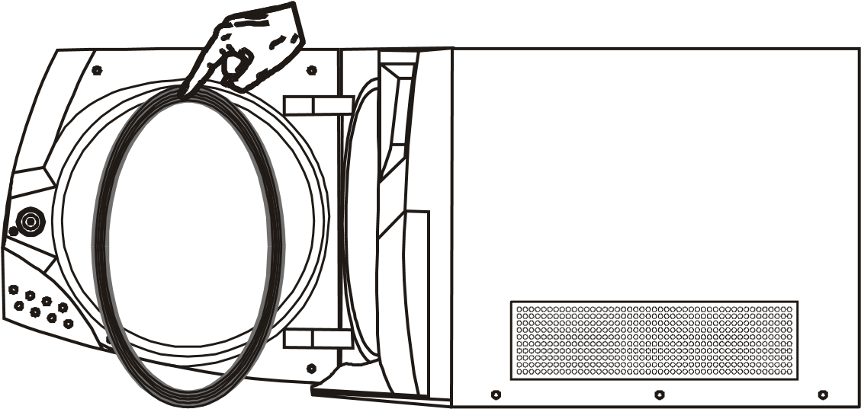

Up

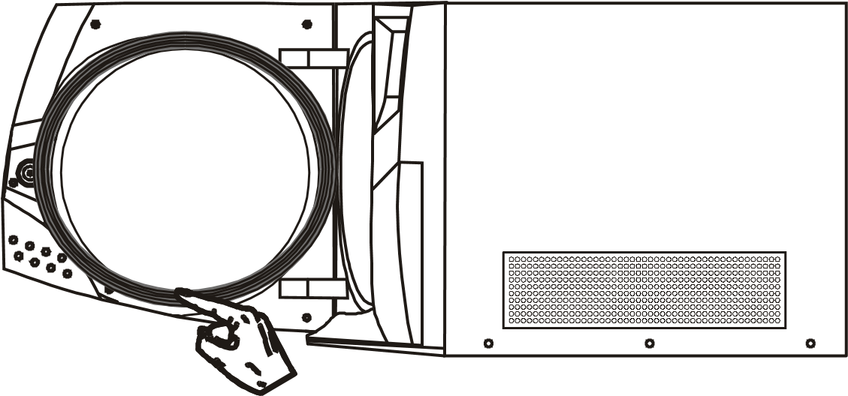
Down

Left and right

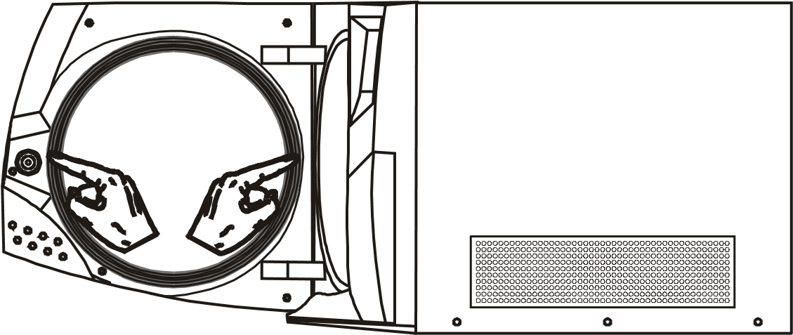
EXAMPLE

Dental Chair

Maintenance of Pelton and Crane Spirit 3000 Dental Chair with Ultraleather Upholstery
EXAMPLE

- Regular cleaning: Use a solution of 10% household liquid dish soap with warm water applied with a soft, damp cloth. Rinse after cleaning with water and allow to air dry. Clean between patients and at the beginning and end of each day.

- Stubborn stains: Use detergent cleaners (Formula 409 or Fantastic). Wipe using a soft cloth or bristle brush. Rinse clean with water and wipe dry.
- For more stubborn stains, use a mild solvent.
- Disinfect ultra leather with a 5:1 bleach solution.

Other Tips:
- Always apply cleaners with a soft white cloth and avoid paper towel.
- When using strong cleaners, always test first in an inconspicuous area.
- Never use harsh solvents that are intended for industrial use.
- To restore lustre, use a light coat of spray furniture wax. Apply to chair, allow to sit of 30 seconds, and lightly buff dry with a clean, dry cloth.

